# **🧠 Convolutional Neural Networks (CNNs) – Complete Guide**

<https://medium.com/@draj0718/convolutional-neural-networks-cnn-architectures-explained-716fb197b243>

* + **ANN's Approach for Image Classification**:  
    - A 28x28 image is **flattened** into a 1D vector, resulting in 784 input values (28 * 28 = 784).
    - These inputs are fed into the input layer, followed by fully connected hidden layers.
    - Finally, there's an output layer, typically a Softmax layer.
  + **CNN's Approach for Image Classification**:  
    - CNNs use the image in its **original 2D form**.
    - **Filters** (e.g., 3x3) are applied to the image.
    - This process generates a **feature map** (e.g., a 26x26 map from a 28x28 input using a 3x3 filter).
    - A **ReLU activation function** is applied to the feature map.
    - A **pooling layer** (e.g., max pooling) is then used.
    - The output is then **flattened**.
    - The flattened output is sent to a **fully connected layer**.
    - Finally, there's a **Softmax layer** for the output.

**ANN Disadvantage**: If an input image size increases (e.g., from 28x28x3 to 1080x1080x3), the number of input nodes in an ANN would increase dramatically. This leads to a **proportional increase in weights** between the input layer and the first hidden layer (calculated as input units * hidden units).

* + - For large images, this means ANNs will have **millions of weights**, resulting in slow training, high computational costs, and an increased chance of overfitting.
    - **CNN Advantage**: The architecture of CNNs ensures that the number of weights remains constant regardless of the input image size, leading to **lower computational cost** and reduced overfitting risk.

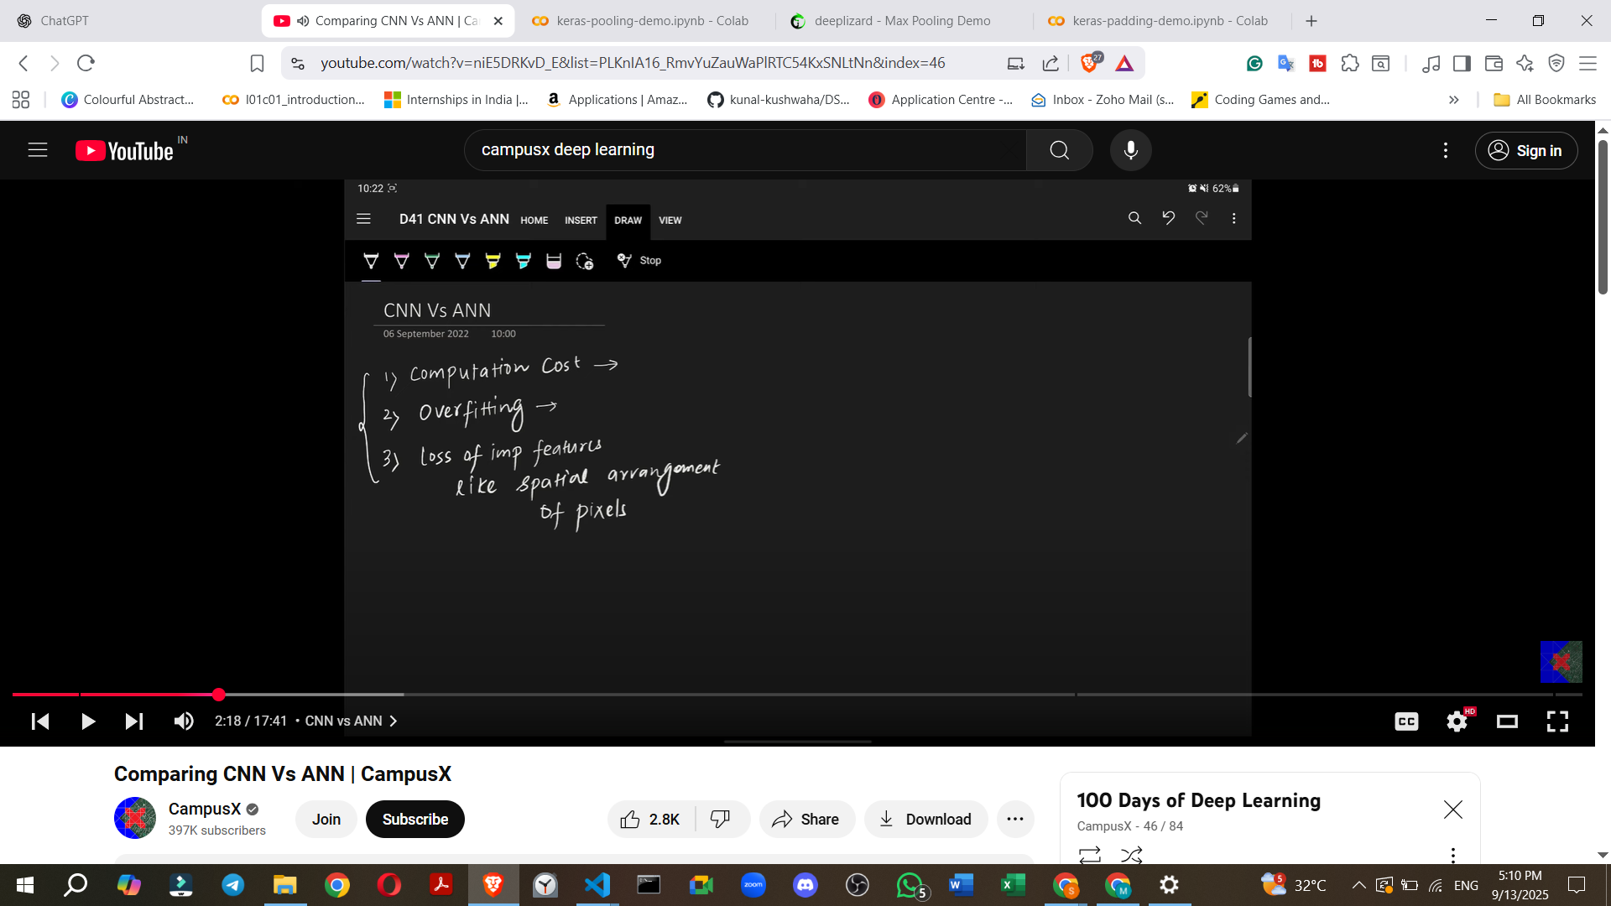

### **Why CNNs are Necessary (Problems with ANNs on Image Data)**

While ANNs can be used for image classification (e.g., achieving about 98% accuracy on the MNIST handwritten digits dataset), CNNs consistently perform better. The primary reasons why ANNs are not ideal for image data are:

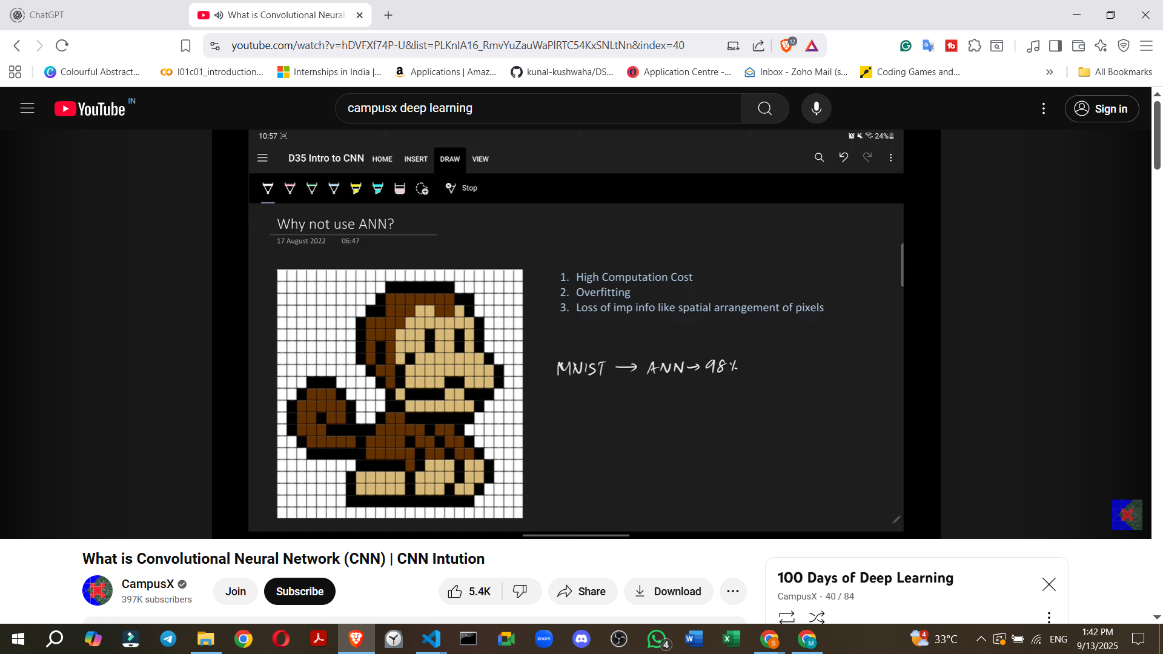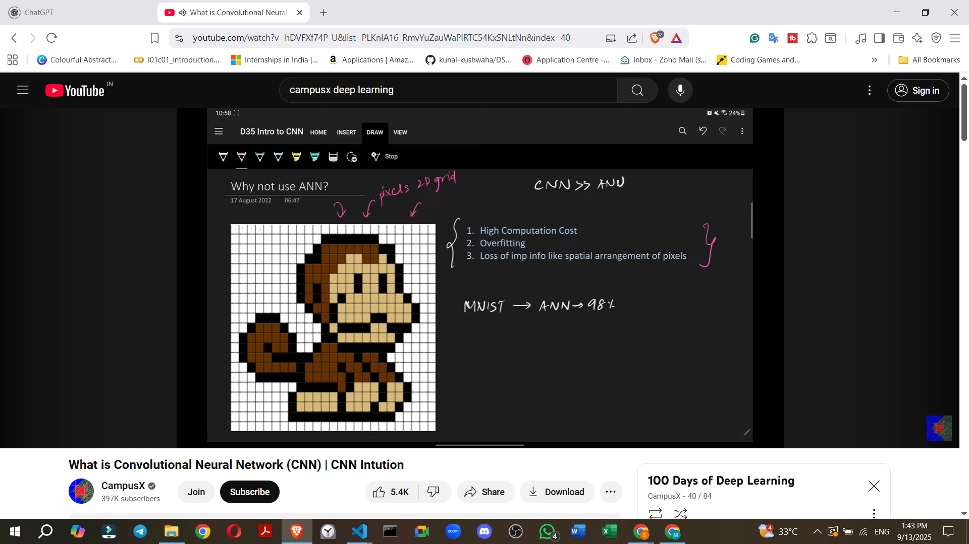

1. **High Computational Cost**:
   * **Image Structure**: An image is essentially a **2D grid of pixels**.
   * **ANN Input Requirement**: For an ANN, this 2D image must be **flattened into a 1D array** of numbers. For example, a 40x40 pixel image has 1600 pixels, which become 1600 numbers in a 1D array.
   * **Weight Explosion**: When these 1D pixels are connected to a fully connected hidden layer, the number of weights becomes extremely large.
     + **Example**: For a small 40x40 pixel image (1600 pixels) connected to a modest hidden layer with 100 units, the number of weights in just the first layer would be **1600 * 100 = 160,000 weights**.

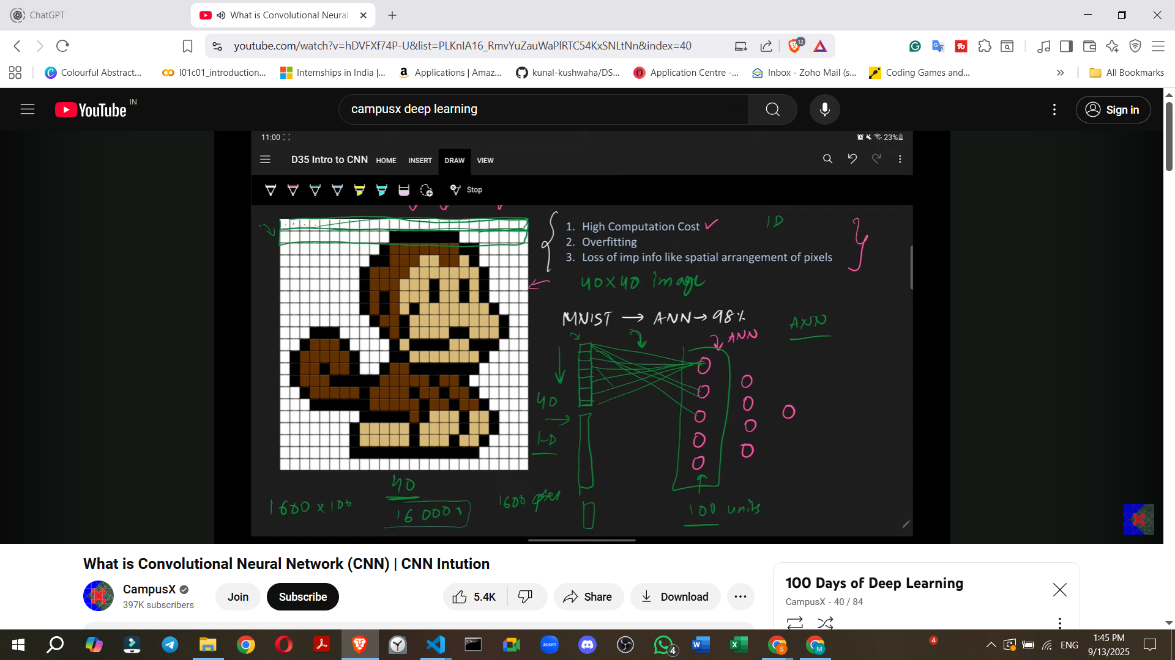

* + **Consequence**: As image sizes increase (e.g., 1000x1000 pixels) or the number of hidden units grows, the number of weights can reach millions or billions, leading to **immense computational costs** and significantly longer training times.

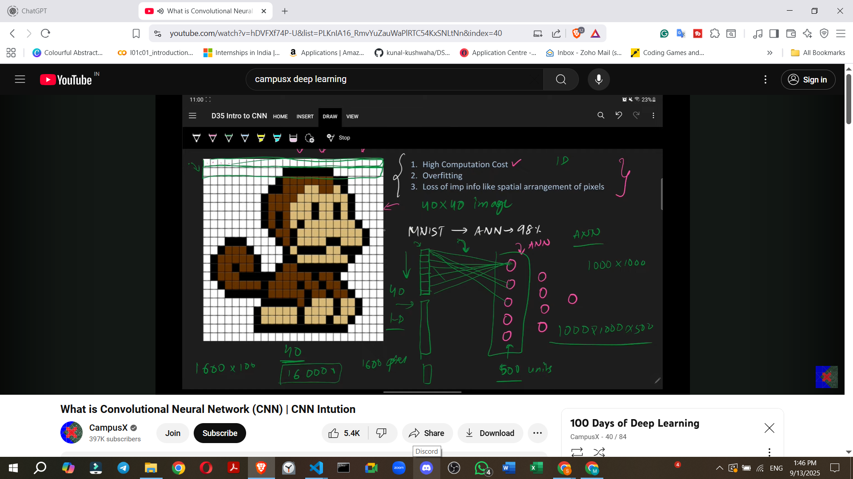

1. **Overfitting**:
   * By connecting every single pixel to every node in the subsequent layer, an ANN attempts to learn and capture every minute pattern in the image, no matter how insignificant.
   * **Consequence**: This exhaustive learning often leads to **overfitting**, where the model performs exceptionally well on the training data but fails to generalize and performs poorly on new, unseen test data.
2. **Loss of Spatial Arrangement**:
   * **Crucial Features**: The spatial arrangement and relationships between pixels (e.g., the distance and relative position of a monkey's eye and nose) are **very important features** for identifying objects in an image.

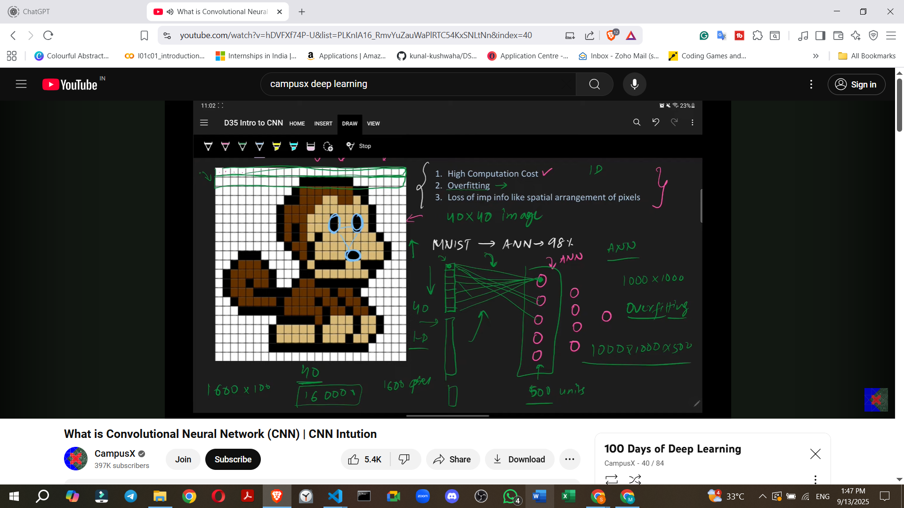

* + **Flattening Issue**: When a 2D image is converted into a 1D array for an ANN, this critical **spatial context and arrangement are completely lost**.
  + **Consequence**: The loss of these inherent 2D features severely hampers the ANN's ability to effectively classify images, leading to less accurate results compared to CNNs.

## 

## **1. 🔎 Introduction**

A **Convolutional Neural Network (CNN)** is a type of **deep learning model** specifically designed to process data with a **grid-like topology**, such as:

* Images (2D grid of pixels)
* Videos (sequence of image frames)
* Audio (1D grid of waveforms)

👉 CNNs are the backbone of **computer vision** tasks like object detection, face recognition, and medical image analysis.

## **Inspiration Behind CNN and Parallels With The Human Visual System**

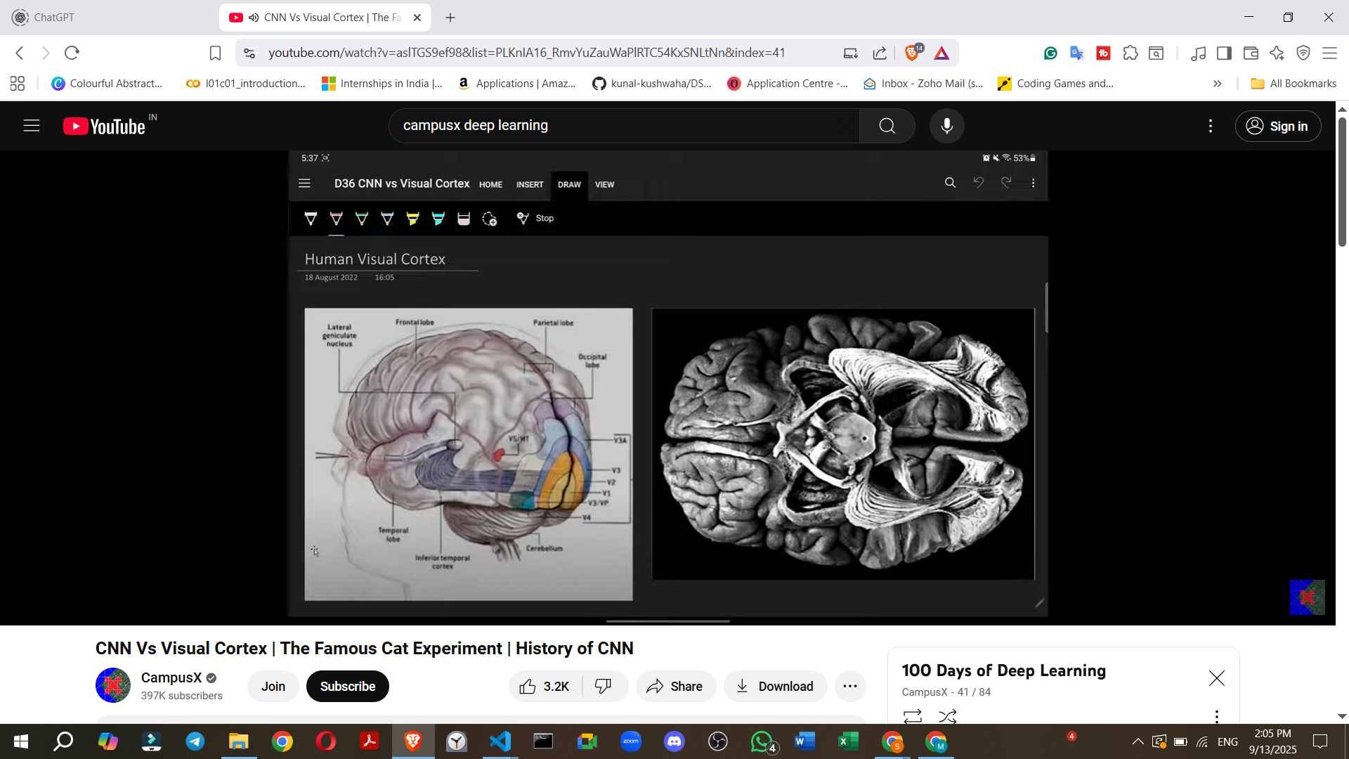

**Flow Summary:** Light -> Retina -> Optic Nerves -> Lateral Geniculate Nucleus (LGN, for pre-processing) -> Primary Visual Cortex (V1).

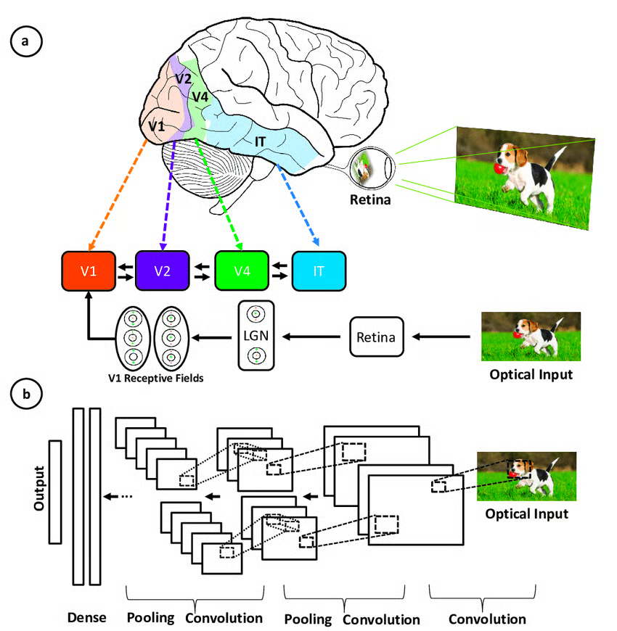

**biological connection of Convolutional Neural Networks (CNNs) to the human visual cortex**. The architecture of CNNs is inspired by our own visual cortex, which is a part of our brain.

### **The Hubel and Wiesel Experiment (The Famous Cat Experiment)**

This section describes a pivotal experiment conducted by **Hubel and Wiesel** around the **1960s**.

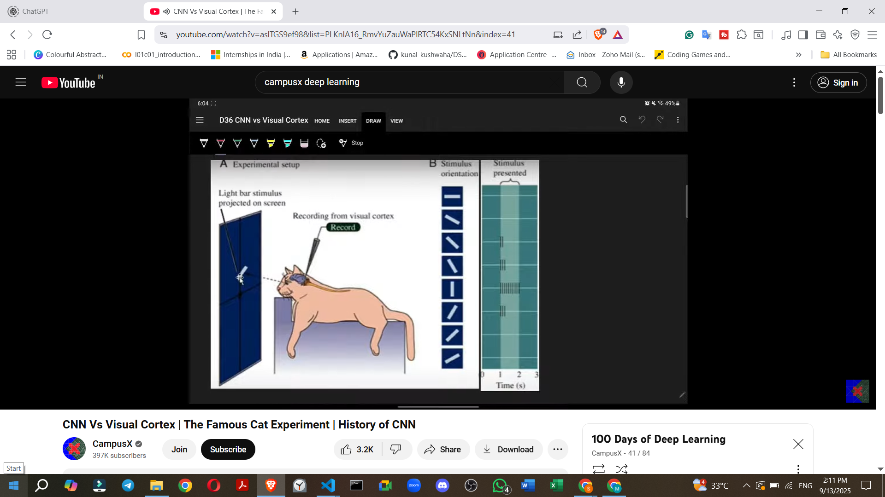

* + The visual cortex is structured such that simple cells detect basic features (like edges), and then complex cells combine these basic features to detect more complex patterns.

### **Connection to Convolutional Neural Networks (CNNs)**

The principles discovered from the Hubel and Wiesel experiments became a significant **inspiration for computer scientists**.

* **Modern CNNs**
  + **Yann LeCun (1990s):** He developed his own **CNN architecture** in the 1990s.
  + **Key Components:** His architecture incorporated **backpropagation** and **pooling layers**.
  + **Application:** This model was highly effective for **scanning checks**.
  + **Significance:** This marked the **beginning of serious research into CNNs**.
  + **AlexNet (2012):** A significant breakthrough occurred in 2012 when **AlexNet** won the **ImageNet competition**, showcasing the power of CNNs.  
    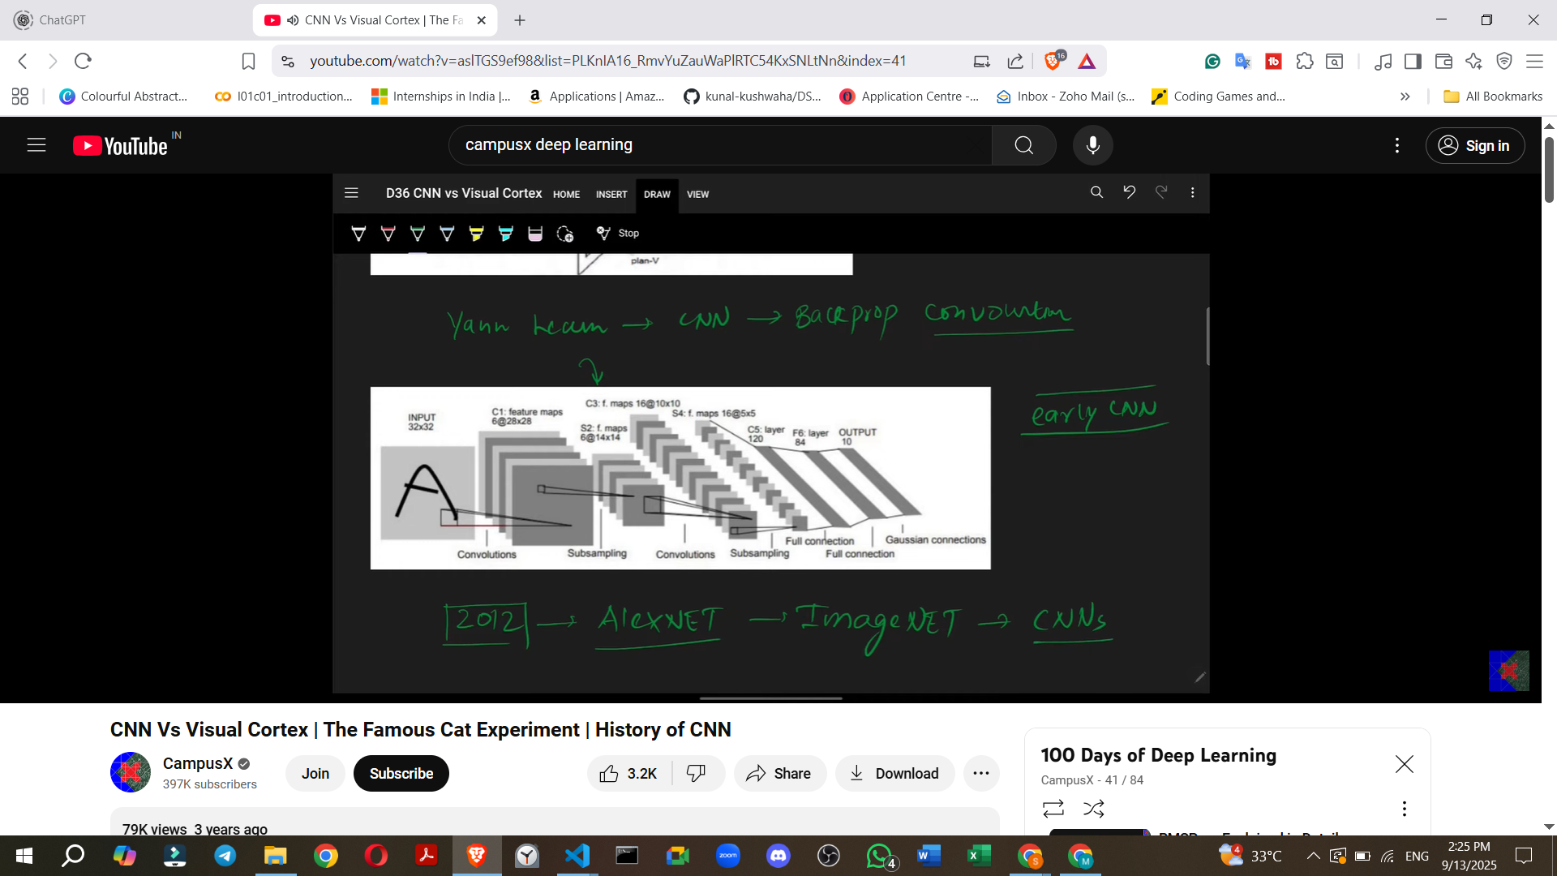
  + **Further Developments:** Since then, many other CNN architectures have emerged and are continuously being developed.

## **2. 🎯 Why CNNs?**

* Traditional **fully connected neural networks (MLPs)** treat each pixel as independent → lose spatial relationships.
* Images are **high-dimensional**; feeding raw pixels into MLPs leads to huge parameter counts.
* CNNs **preserve spatial relationships** (edges, shapes, objects) and drastically **reduce parameters** by weight sharing.

### **6. How CNNs Work: Intuition and Feature Extraction**

CNNs approach image classification by mimicking how the human brain identifies objects.

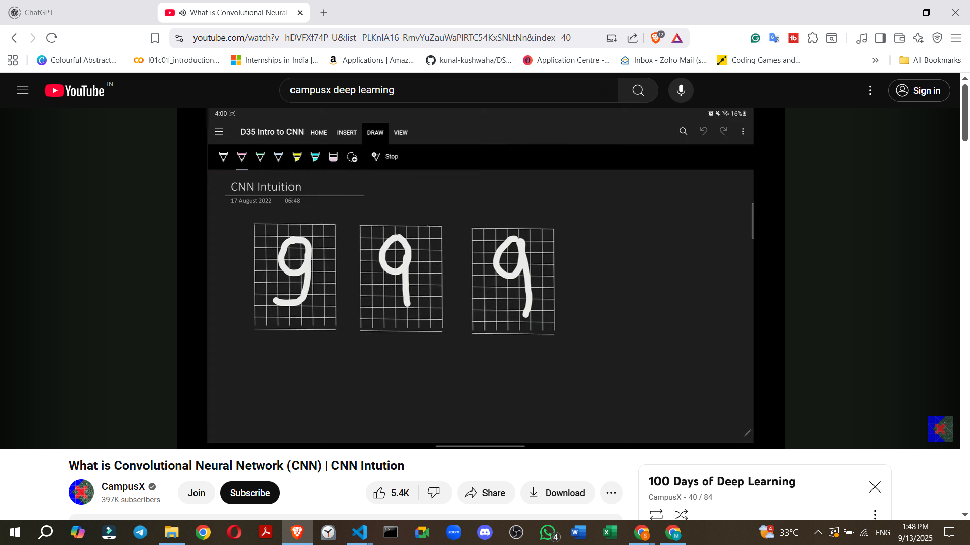

* **Human Brain Analogy**:
  + Consider classifying the digit '9'. Our brain doesn't just see a whole '9'; it looks for specific patterns: a **circle**, a **vertical line**, and a **horizontal line**.

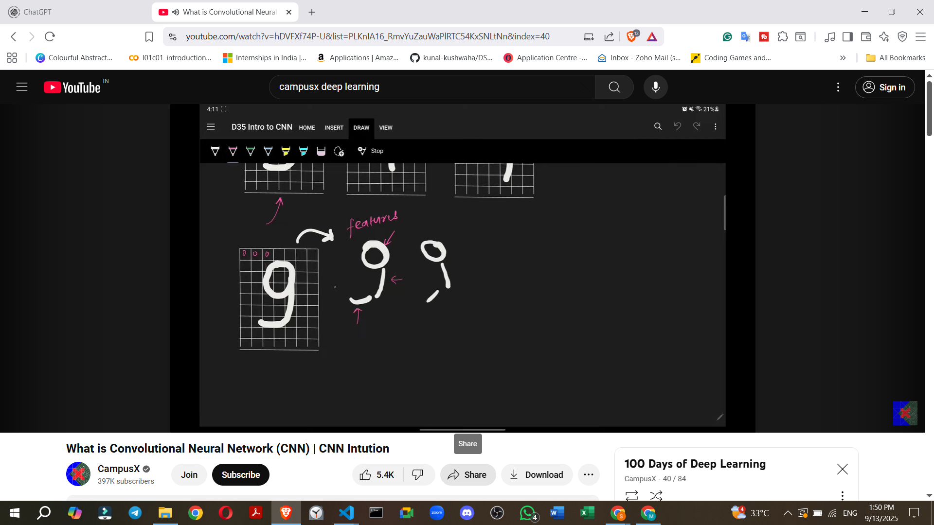

* + Even if these patterns are slightly distorted (e.g., a slightly imperfect circle or angled lines), our brain can still recognize the '9'.
  + This process involves **breaking down the digit into its component features**.
* **CNN Mechanism**:
  + **Primitive Feature Extraction**: When a CNN receives an image, its initial convolutional layers focus on extracting **primitive features** such as **edges** (horizontal, vertical, diagonal lines, corners).

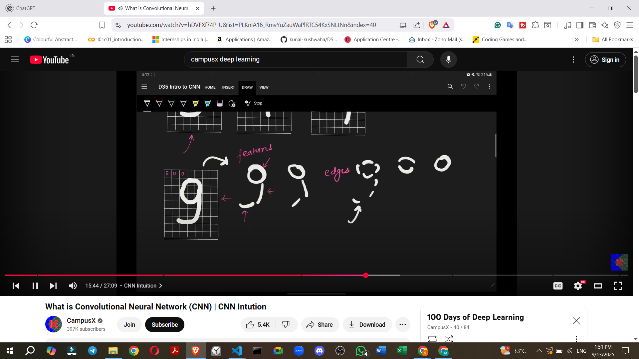

* + - **Example**: For a '9', the CNN first identifies the basic edges that form the circle, the vertical stem, and the horizontal base.

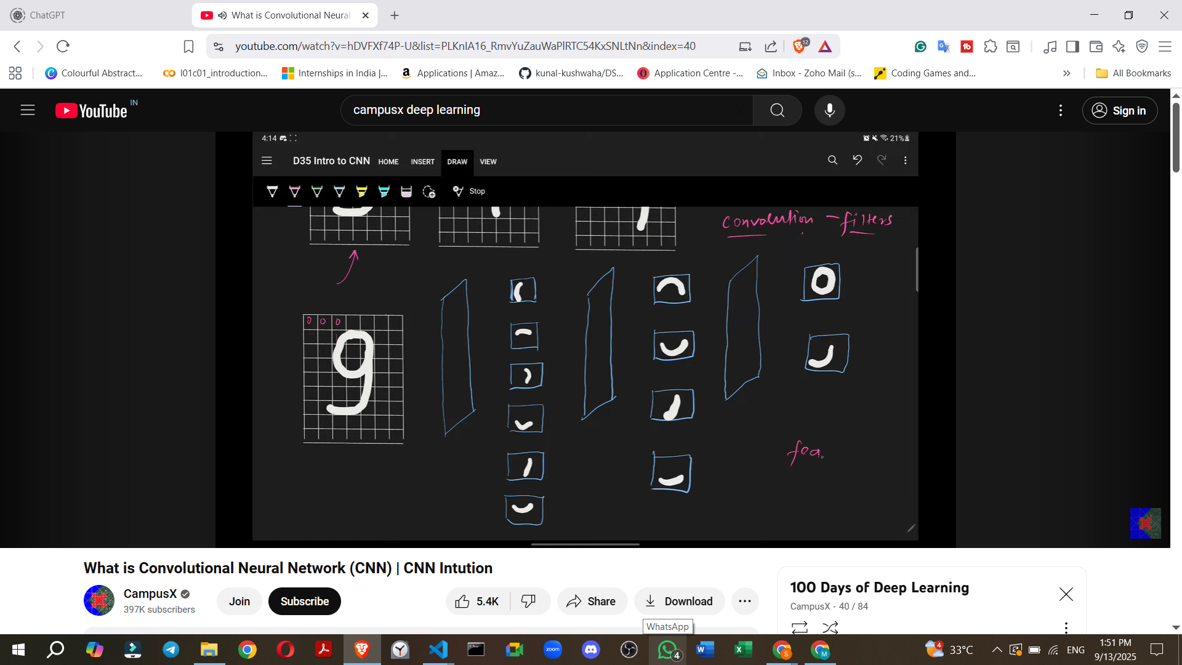

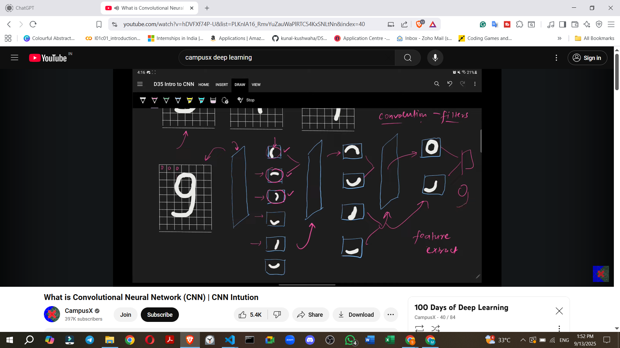

* + **Filters/Kernels**: Convolutional layers employ **"filters"** (also known as kernels). These are small matrices that "slide" or "move" across the input image.
    - The purpose of these filters is to **detect specific patterns or features** within the image.
    - When a filter matches a particular pattern (e.g., a vertical edge), that feature becomes "activated".

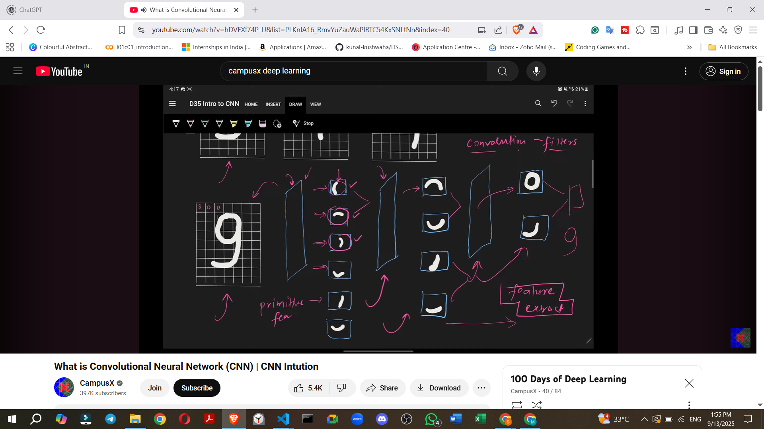

* + **Building Complex Features**:
    - The primitive features extracted by earlier layers are then passed to subsequent convolutional layers.
    - These deeper layers combine the simpler features to build more **complex and meaningful features**.
    - **Example (Digit 9)**: Edges are combined to form semi-circles, which are then combined to form a full circle. Simultaneously, other edges are combined to form lines.



* + - **Example (Cat Image)**: Initial layers might detect simple edges. Middle layers would combine these edges to form more complex parts like **ears, eyes, or a mouth**. The deepest layers would then combine these parts to recognize a **full face or body of a cat**, allowing the CNN to classify the image as a "cat".
  + **Deep Learning Principle**: As the CNN gets progressively "deeper" (more layers), it extracts increasingly abstract and complex features, moving from primitive edges to high-level conceptual components, ultimately leading to accurate classification.

**Convolution Operation: The Fundamental Building Block**

The convolution operation is responsible for **extracting features** from an image.

**Edge Detection**: A common initial feature extracted by convolution layers is **edges**.

◦ **What are Edges?**: Edges represent a **change in intensity** within an image.

◦ **Example**: If an area of an image is black (low intensity) and then suddenly transitions to white (high intensity), that transition forms an edge.

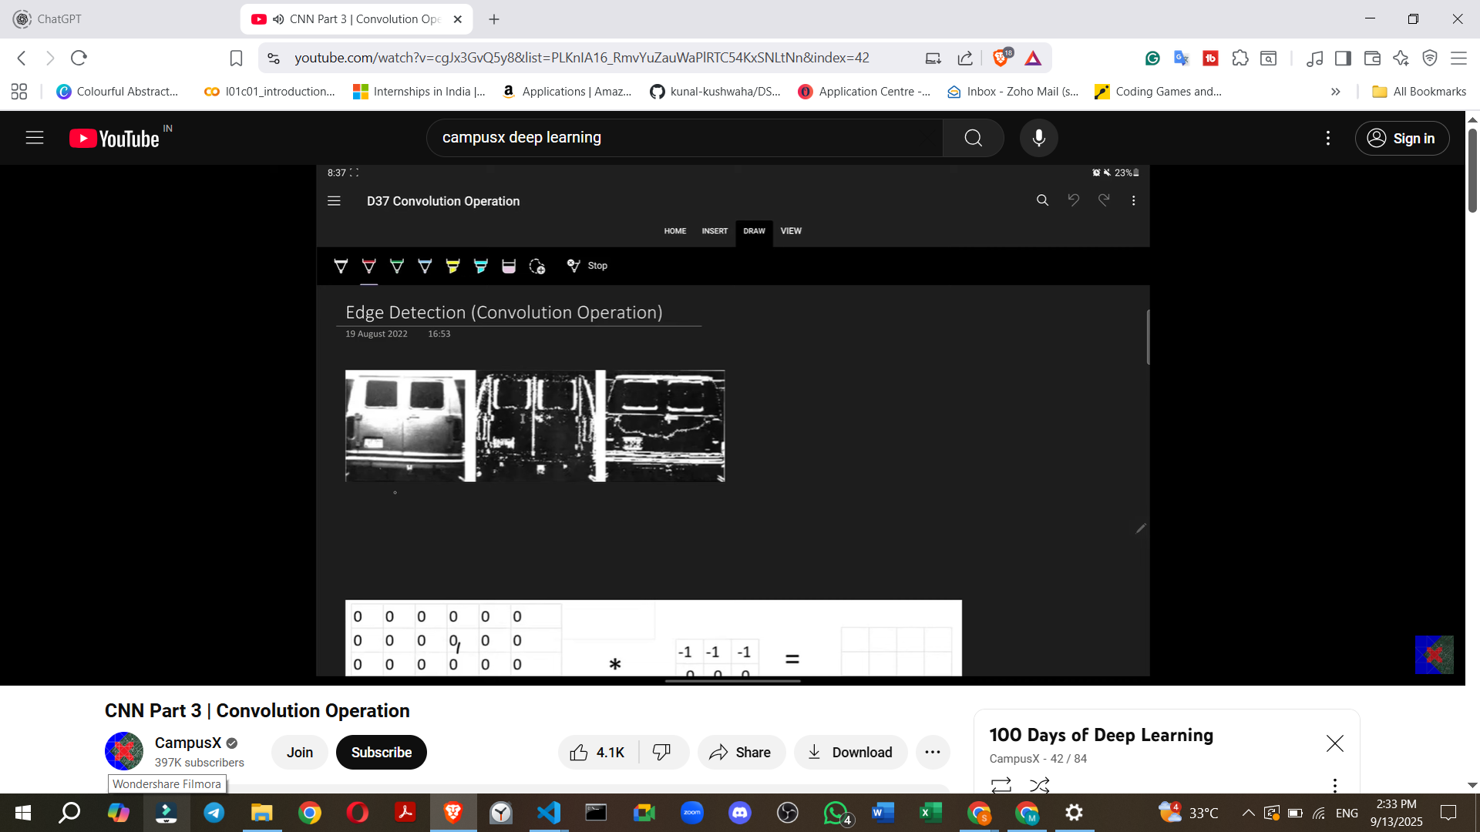

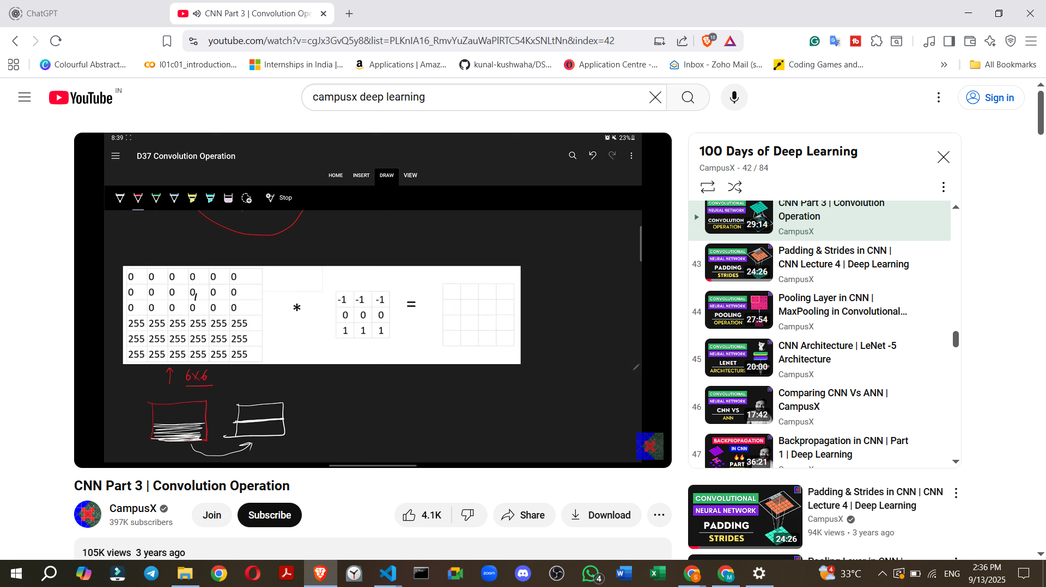

. **Filter (Kernel)**: A small matrix of numbers, typically 3x3, used to detect specific features.

▪ **Example (Horizontal Edge Detector Filter)**:

▪ This specific filter is designed to detect horizontal edges.

## 

## **3. ⚙️ CNN Architecture Components**

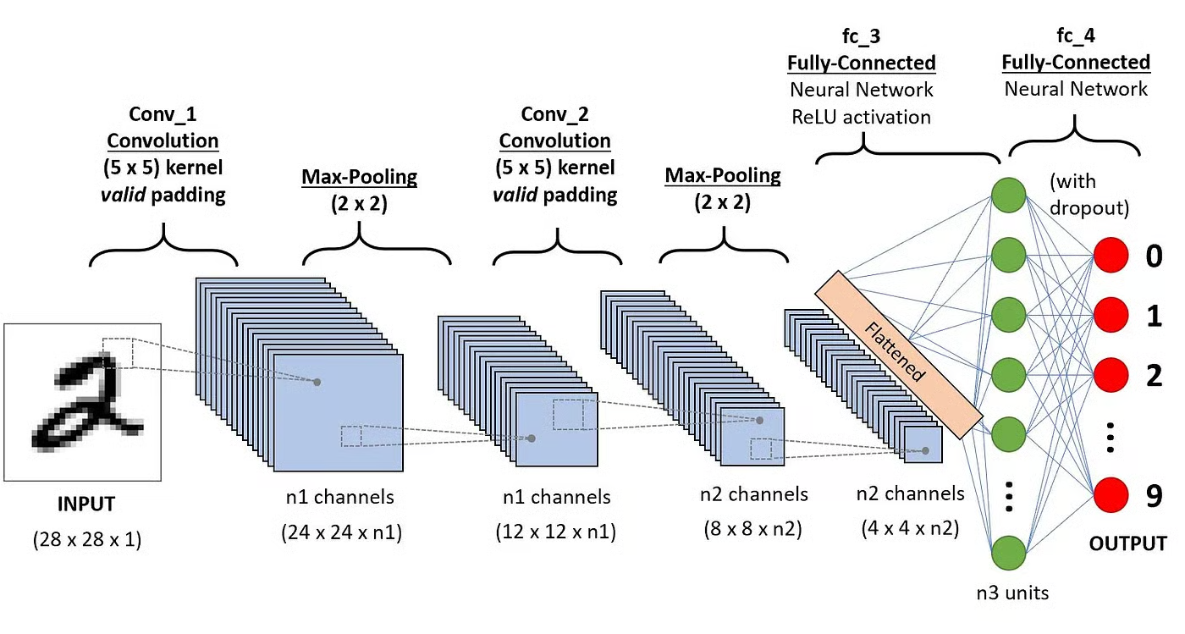

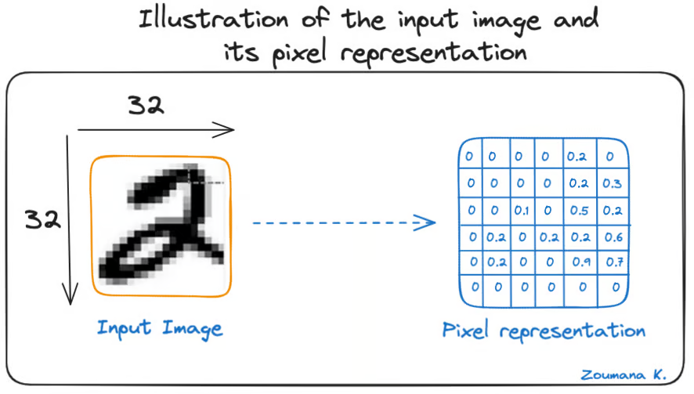

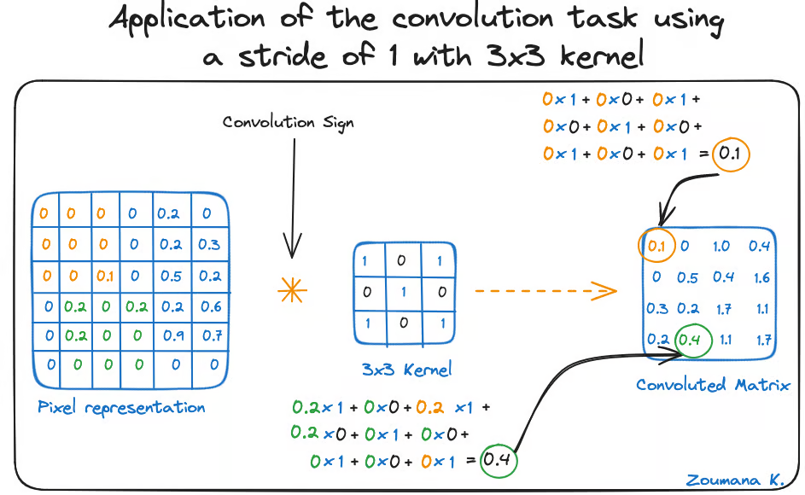

### **(a) Convolution Layer**

* **Core operation** of CNN.
* Uses a **filter (kernel)** that slides across the input image.
  + <https://deeplizard.com/resource/pavq7noze2>

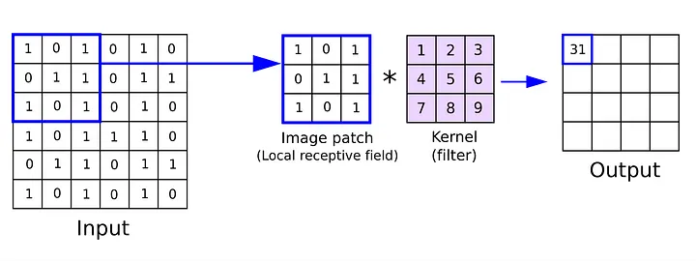

* Each filter detects a feature (edges, corners, textures, patterns).
* Formula for convolution (2D case):

[  
 S(i,j) = \sum_m \sum_n I(i+m, j+n) \cdot K(m,n)  
 ]

where:

* (I) = input image
* (K) = kernel
* (S) = feature map (output)

👉 **Weight sharing**: same kernel applied across the whole image.

<https://poloclub.github.io/cnn-explainer/>

### **(b) Padding**

* Adds extra pixels around image borders.

**Need for Padding**

* Before discussing padding, it's essential to understand *why* it's needed.
* When a filter is convolved over an image, the resulting feature map is **smaller** than the original image.
  + For example, a 5x5 image convolved with a 3x3 filter results in a 3x3 feature map.
* **Problem 1: Reduction in Resolution/Information Loss**
  + If multiple convolutional layers are applied consecutively, the image size will continuously decrease.
  + This leads to a loss of information with each layer, which is generally undesirable.
* **Problem 2: Underrepresentation of Border Pixels**
  + Pixels at the borders (sides, top, bottom) of an image are part of fewer convolution operations compared to the central pixels.
  + For instance, a pixel in the top row might participate in only one convolution operation, while a central pixel could be part of three to four operations.
  + This means that when the feature map is generated, the central pixels have a greater "say" or importance, while the side pixels' influence is reduced.
  + If crucial information is located at the borders, it might not be effectively filtered out and represented in the feature map.
* Padding solves both these problems.

**3. What is Padding?**

* Padding involves **adding rows and columns** around the border of an image.
* Typically, these added pixels have a value of **zero**, which is why it's often referred to as **zero-padding** in literature.
* **How it works (Example):**

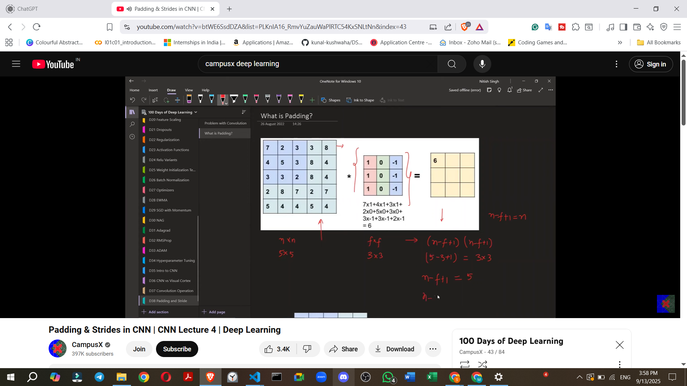

* Types:  
  + **Valid padding** → no padding (output smaller).
  + **Same padding** → padding added so output = input size.

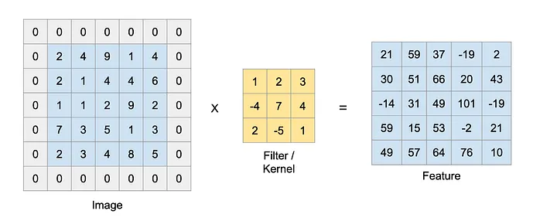

### **(c) Stride**

* Number of steps kernel moves each time.
* The stride value defines **how many pixels the filter shifts** (or "steps") across the input image after each convolution operation.
* Stride = 1 → detailed scanning.
* Stride > 1 → faster, reduces output size.  
  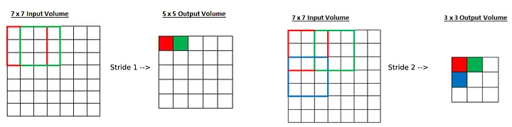
* Using a stride greater than one is sometimes called "strided convolution".
* There are **two primary reasons** for using strided convolution:
  + **1. Focusing on High-Level Features:**
    - A small stride (e.g., 1) captures fine details or "low-level features" in an image.
    - A larger stride causes the CNN to "jump through" information, essentially skipping many pixels.
    - This results in the CNN capturing only "high-level" or "coarse" features, which might be sufficient or desired for certain computer vision problems.
  + **2. Reducing Computational Power/Speeding up Training:**
    - A larger stride means fewer convolution operations are performed.
    - This can significantly speed up the training process, especially for very large datasets.
    - **Note:** This reason has become less critical in recent years due to increased computing power, so many models now often use a default stride of 1. However, strides are still relevant for specific problems.

### **(d) Activation Function (ReLU)**

* After convolution, apply **non-linearity** (e.g., ReLU).
* (\text{ReLU}(x) = \max(0, x))
* Helps CNN learn **complex, non-linear patterns**.

### **(e) Pooling Layer**



* Reduces spatial size (downsampling).

### **2. Why Pooling is Necessary: Problems it Solves**

Before understanding the pooling operation, it's important to understand its necessity within a CNN. When applying a convolution operation, two main problems arise:

**Problem 1: Memory Issues**

* Convolution operations can require a significant amount of memory, potentially causing a program to crash.
* **Example**: For an input image of 228x228x3 (standard for many good CNN architectures) and applying 100 filters of 3x3x3, the resulting feature map would be 226x226x100.
* If these numbers are stored using 32-bit floating-point values, this single training data point would occupy around 900 MB of RAM.

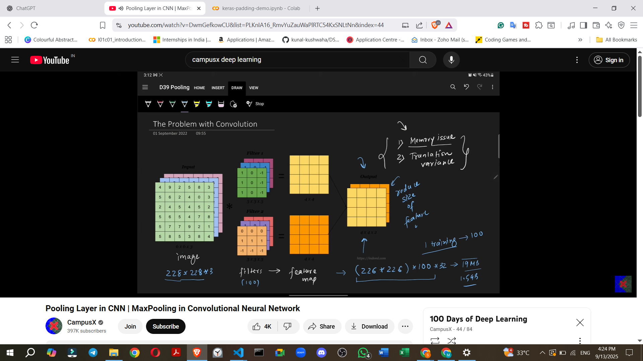

* For a batch size of 4, this could amount to approximately 1.5 GB.
* **Conclusion**: Such large feature maps are not sustainable, necessitating a reduction in their size.
* One possible solution is to increase the stride in convolution, which automatically reduces the feature map size, but pooling is generally preferred because it also addresses the second problem.

**Problem 2: Translation Variance**

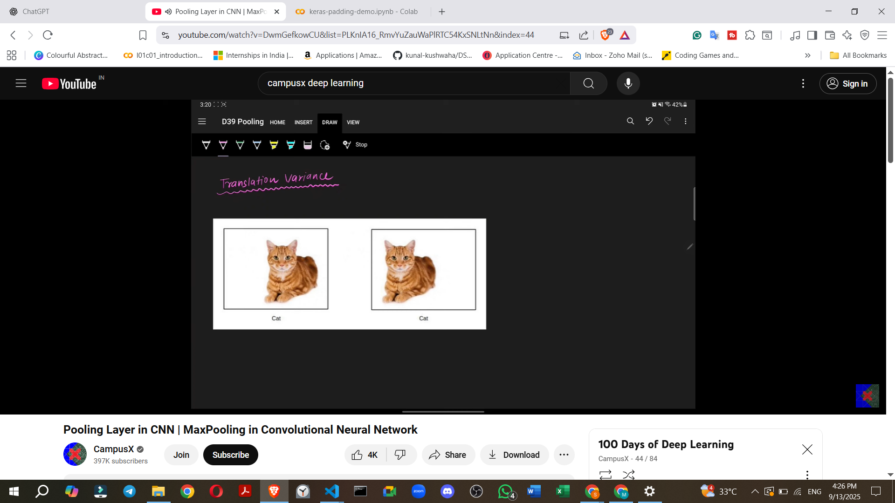

* Convolution operations exhibit translation variance.
* A convolution operation's purpose is to detect features (e.g., eyes, nose, tail of a cat) in images.
* The problem is that the features detected by the CNN become **location-dependent**.
  + **Example**: If a cat's ear is on the left side of the image, features will be detected there. If it shifts to the right, features will be detected on the right.

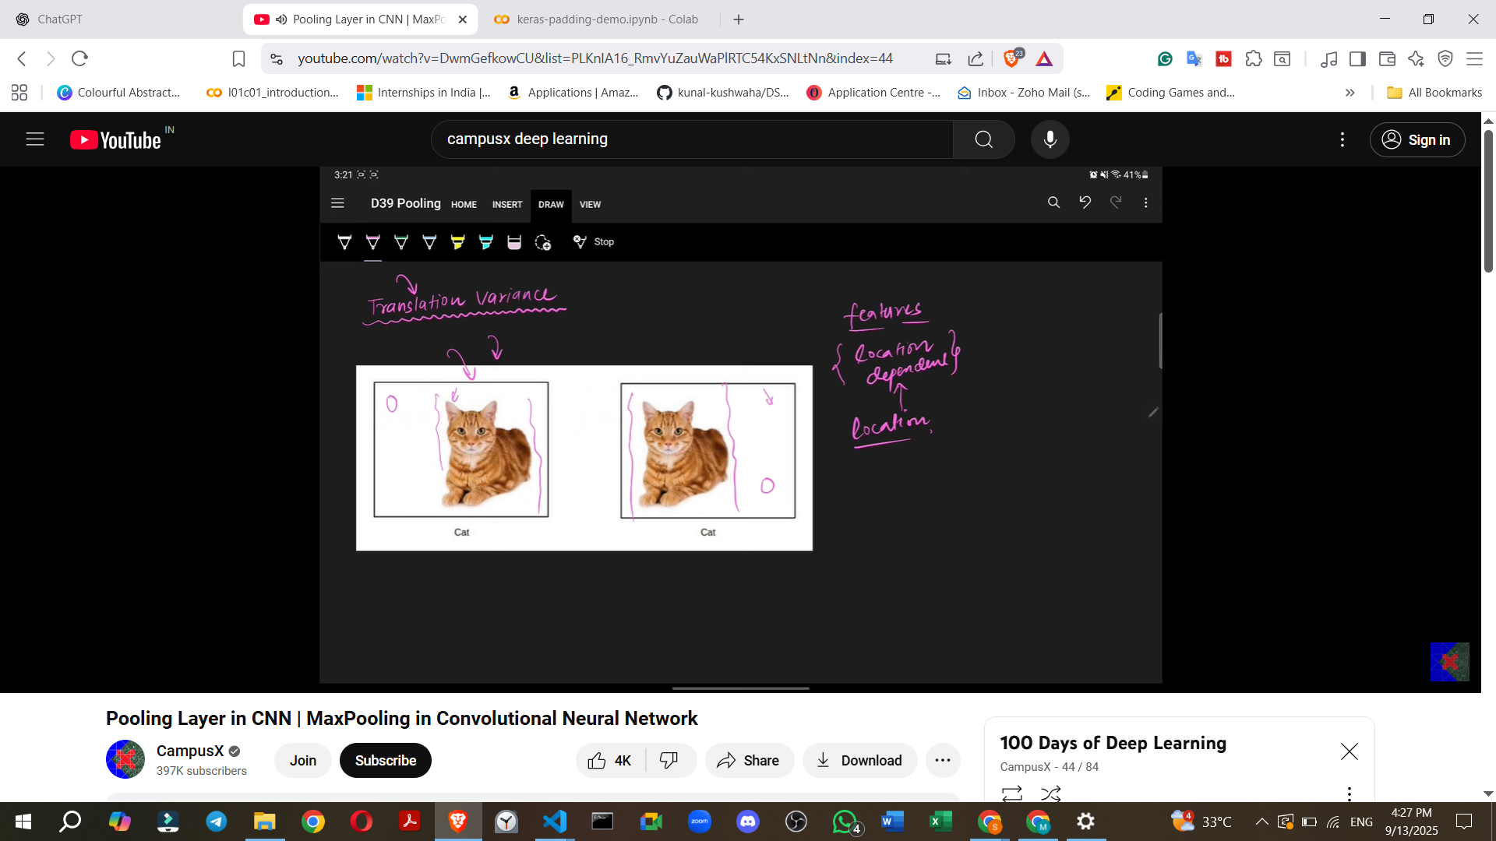

* In image classification tasks (e.g., identifying a cat), the location of a feature does not matter; what matters is the presence of the feature itself.
* If features are location-dependent, subsequent layers might treat the same feature in different locations as distinct, leading to incorrect results.
* **Desired outcome**: **Translation Invariance**, meaning that the location of a feature does not affect its identification or treatment by the model. Pooling helps achieve this.

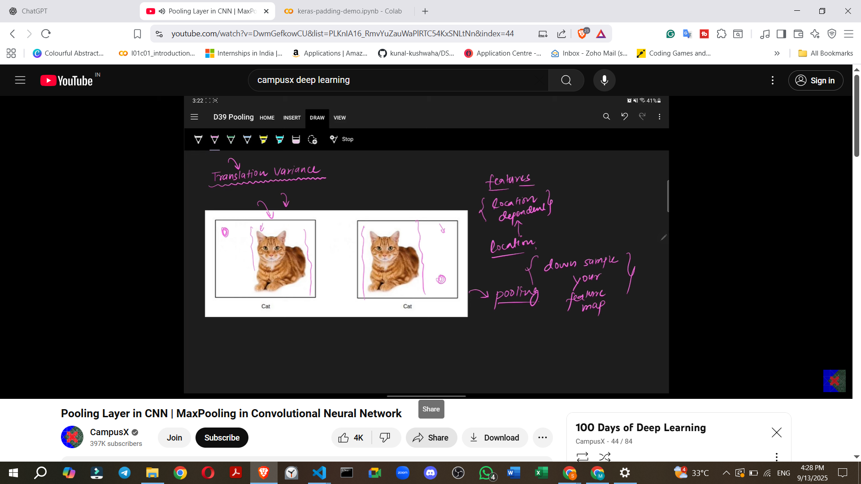

**Types of Pooling Operations**:

* **Max Pooling** (most famous and commonly used).
* **Mean Pooling**.
* **Average Pooling**.
* **L2 Pooling**.
* **Global Pooling**.

**How Max Pooling Works (Detailed Example)**:

* Suppose you have a 4x4 feature map with numbers.

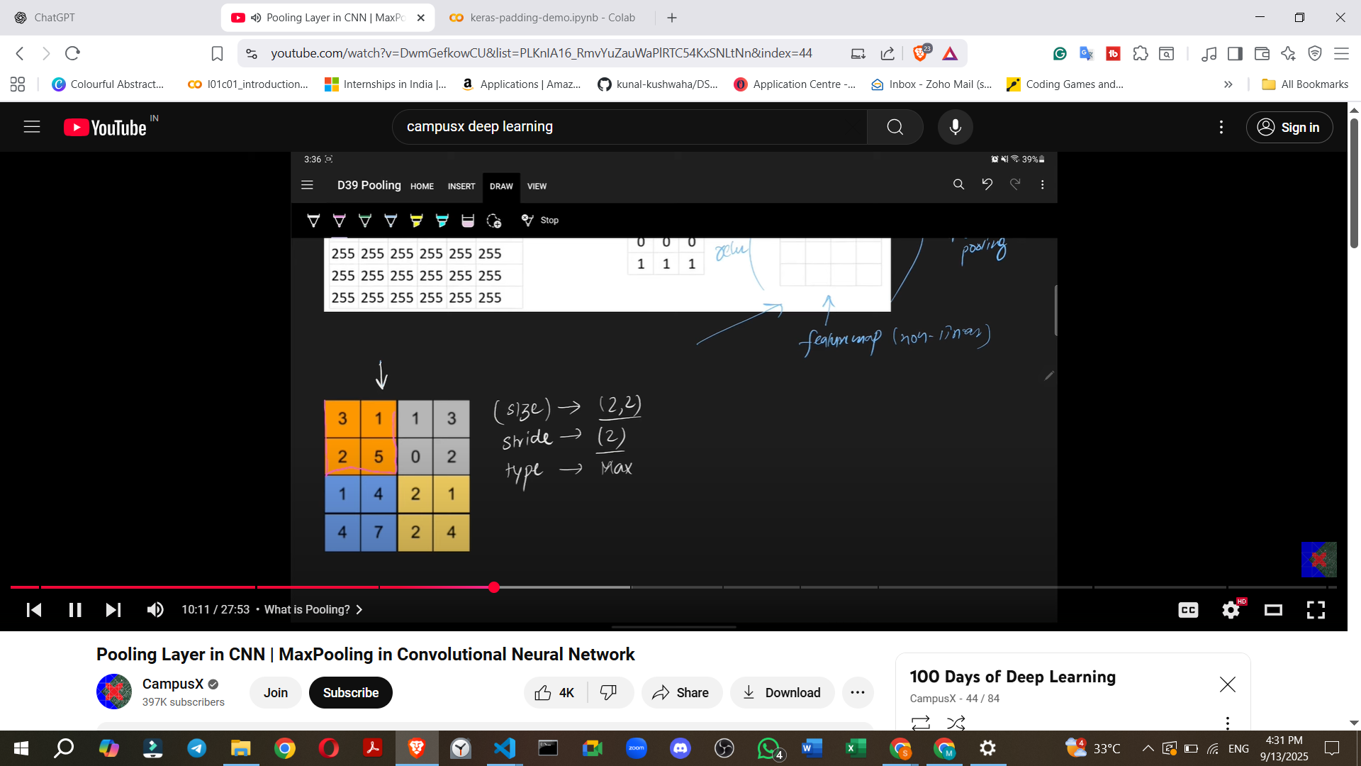

* To apply a pooling operation, you specify three things:  
  1. **Window Size**: Typically 2x2, but can be changed.
  2. **Stride**: Typically 2, but can be changed.
  3. **Type of Pooling**: e.g., Max Pooling.
* **Enhances Features (Specific to Max Pooling)**.



* 1. Max Pooling works by extracting the most dominant features from a local receptive field.
  2. This process can result in a feature map where the detected features appear more pronounced or "bright". Other pooling types like Mean Pooling do not offer this specific advantage.
* Example: 2×2 max pooling reduces a 4×4 feature map → 2×2.

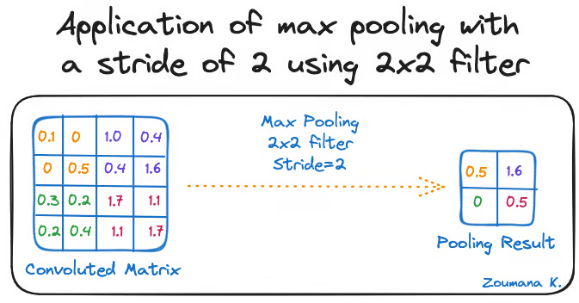

👉 Reduces computation + prevents overfitting.

### **8. Disadvantages of Pooling**

While beneficial, pooling has its drawbacks:

1. **Not Suitable for All Tasks (Location Matters)**.  
   * The translation invariance provided by pooling is excellent for image classification (where "cat or not cat" is the question, not "where is the cat?").
   * However, for tasks like **image segmentation** (dividing an image into distinct regions), the **location of features is crucial**. In such cases, pooling may not be used as extensively.

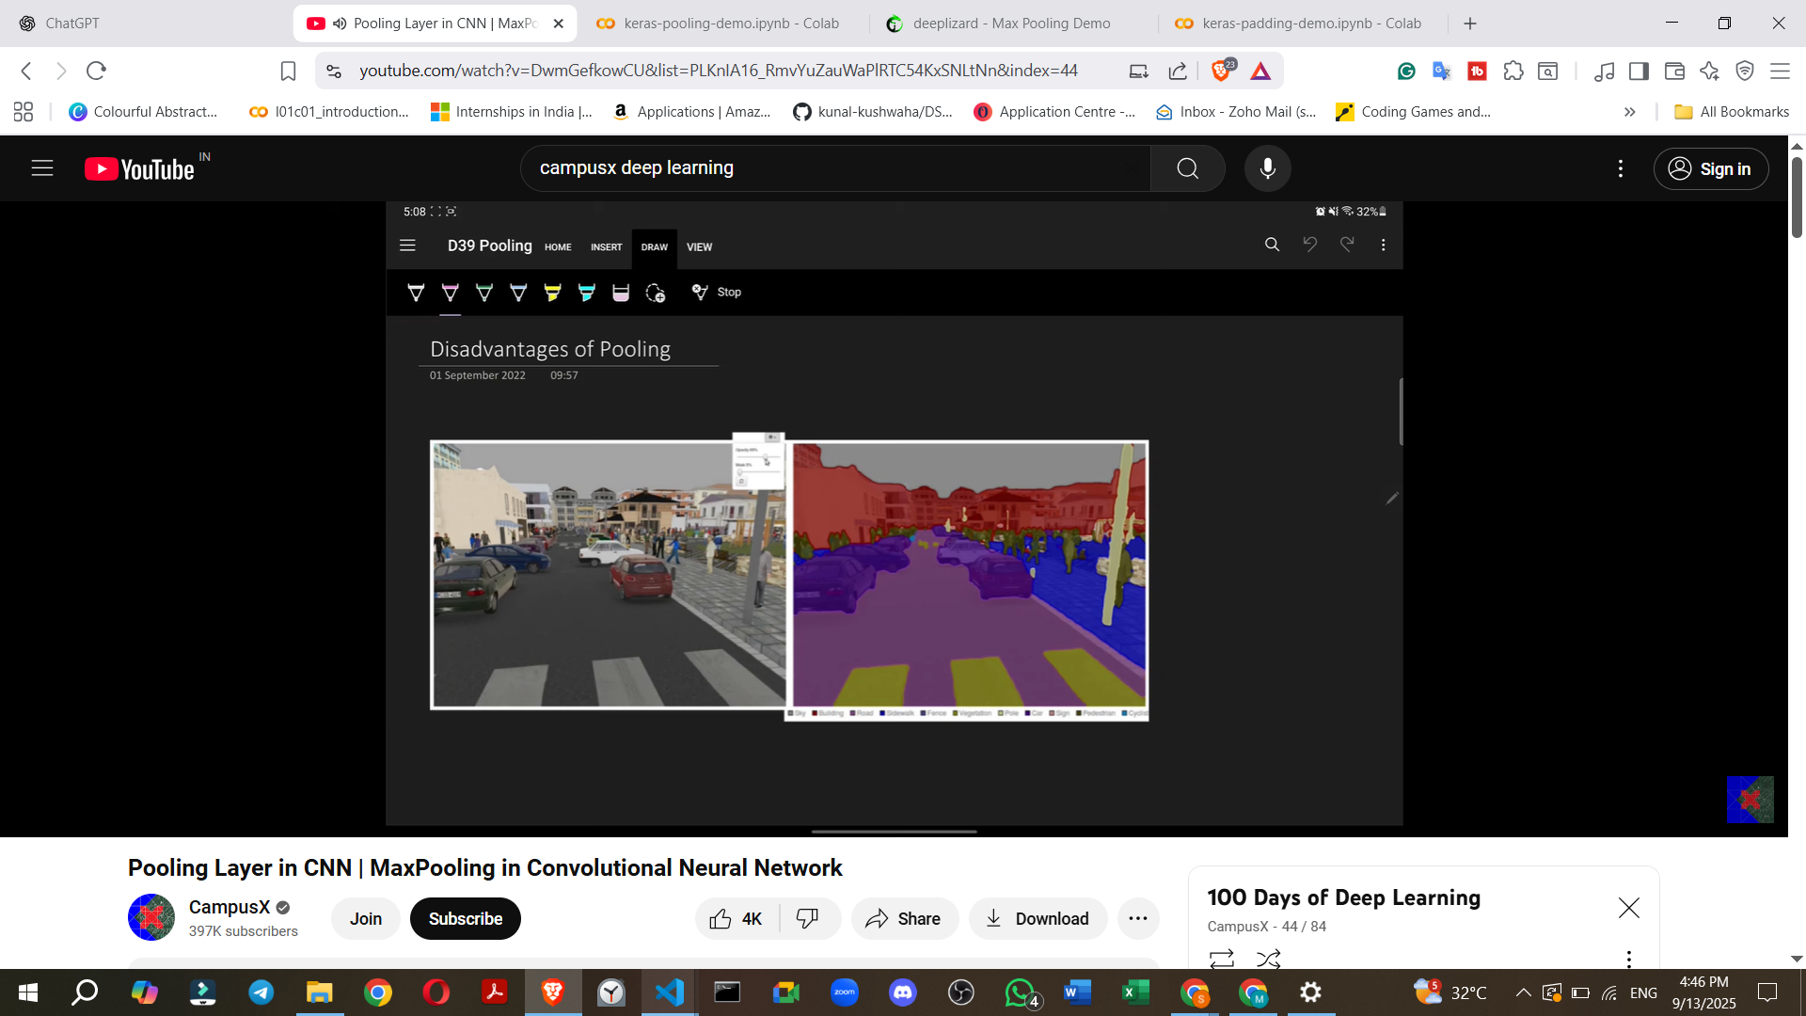

1. **Loss of Information**.  
   * Pooling is a downsampling operation that discards a significant amount of data.
   * **Example**: Reducing a 4x4 feature map to 2x2 means you are retaining only 4 out of 16 values, effectively losing about **75% of the information**.
   * Whether this information loss is detrimental or acceptable depends on the specific application being built.
   * It's worth noting that some research papers have shown that respectable accuracies can be achieved in CNNs even **without pooling**, relying solely on convolutional layers.

### **(f) Flattening**

* Converts 2D feature maps into a 1D vector before feeding into fully connected layers.

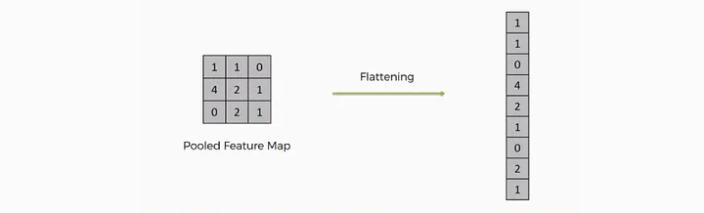

### **(g) Fully Connected Layer (Dense Layer)**

* After feature extraction, fully connected layers **combine features** to classify images (softmax for multi-class).

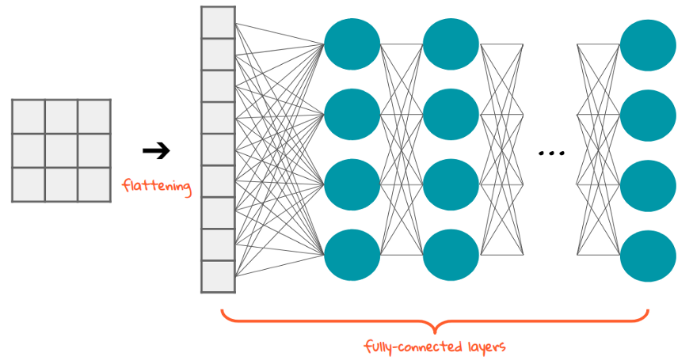

### **(h) Dropout**

* Randomly deactivates neurons during training.
* Prevents **overfitting**.

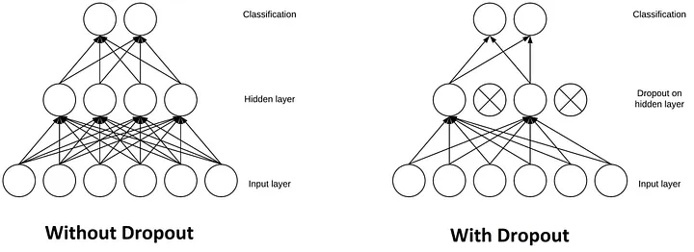

<https://stanford.edu/~shervine/teaching/cs-230/cheatsheet-convolutional-neural-networks>

## **4. 📐 CNN Architecture Example**

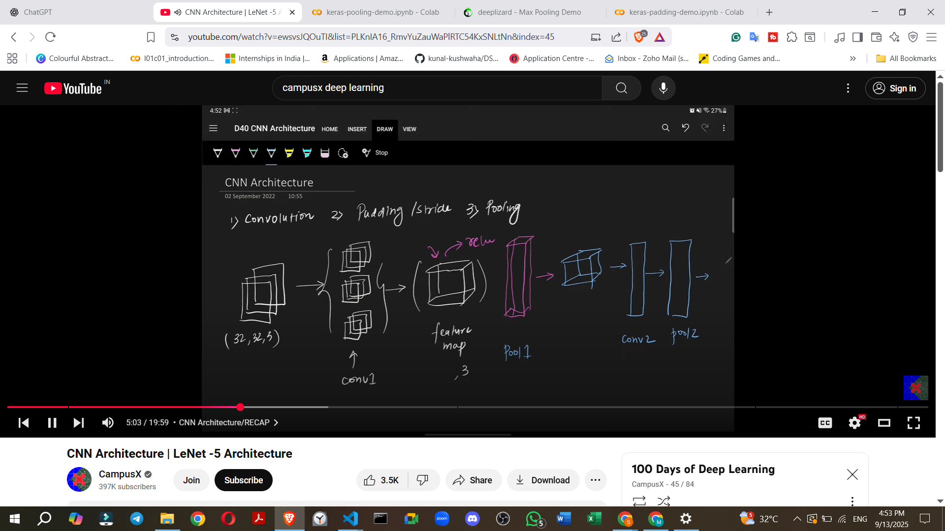

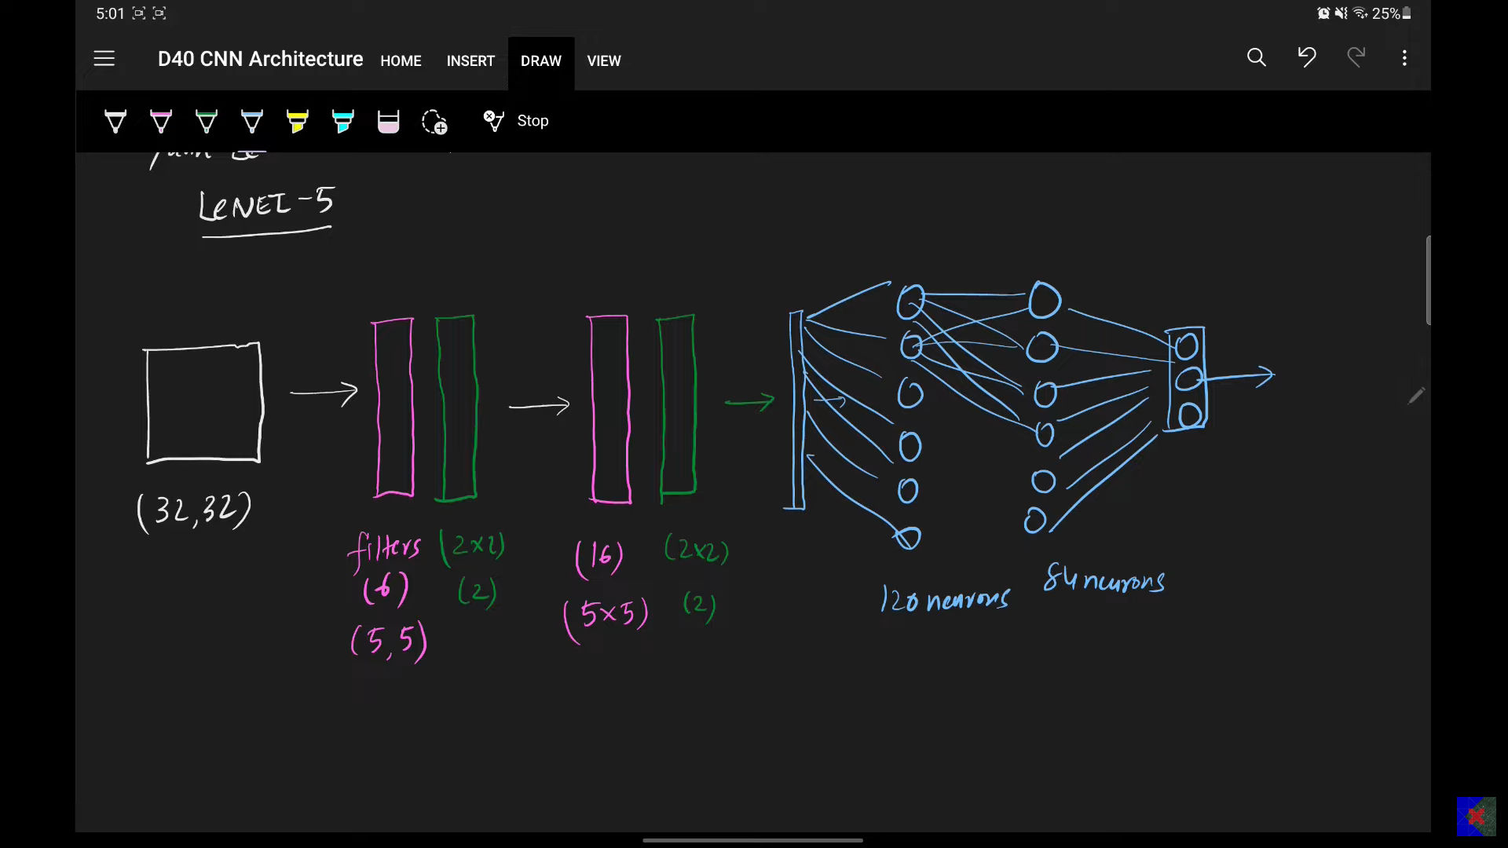

For a 32×32 RGB image:

1. Input: (32 \times 32 \times 3)
2. Conv Layer (5×5 filters, 6 filters): (28 \times 28 \times 6)
3. Pooling Layer (2×2): (14 \times 14 \times 6)
4. Conv Layer (5×5 filters, 16 filters): (10 \times 10 \times 16)
5. Pooling Layer: (5 \times 5 \times 16)
6. Flatten: (400)
7. Fully Connected Layer: 120 → 84 → 10 (classes)

👉 This is similar to **LeNet-5** (one of the first CNNs).

## **5. 🧮 Key Concepts in CNN**

* **Receptive Field**: Region of input influencing one neuron in feature map.
* **Feature Hierarchy**:  
  + Early layers → edges, corners.
  + Middle layers → textures, shapes.
  + Later layers → objects.
* **Parameter Sharing**: Same filter weights reused → efficient.
* **Translation Invariance**: CNN detects objects regardless of their location.

Key Concepts

* **Filters (Kernels)**
* : These are small matrices that are learned during the training process to detect specific features in the input data.
* **Feature Maps**
* : The output of the convolution operation, highlighting the presence of specific features within the input image.
* **Automatic Feature Extraction**
* : Unlike traditional algorithms where filters are manually engineered, CNNs learn the optimal filters automatically from the data.
* **Spatial Hierarchy**
* : CNNs process information hierarchically, from simple features in early layers to complex patterns in deeper layers, much like the human brain.
* **History**:
  + **1998**: **Yann LeCun** developed the first successful convolutional network at AT&T Labs.
  + **Application**: This early CNN was capable of scanning checks and **identifying handwritten digits**.
  + **Subsequent Developments**: Following this, Microsoft developed various OCR (Optical Character Recognition) and handwriting recognition tools, which significantly boosted research in CNNs.
  + **Modern Day**: Today, CNNs are one of the most popular and successful neural networks available. They are integral to applications ranging from **facial recognition software to self-driving cars**. Their impact on society is profound due to their successful real-world implementations.

## 

## **7. ✅ Advantages of CNN**

* Captures spatial features (edges → patterns → objects).
* Fewer parameters vs fully connected networks.
* Translation and distortion invariant.
* State-of-the-art in computer vision.

## **8. ❌ Disadvantages of CNN**

* Computationally expensive (needs GPUs/TPUs).
* Requires large labeled datasets.
* Limited interpretability (black box).
* Vulnerable to **adversarial attacks**.

## **9. 📌 Applications of CNN**

* **Image classification** (dogs vs cats, medical images).
* **Object detection** (YOLO, Faster R-CNN).
* **Face recognition** (security, social media).
* **Medical imaging** (tumor detection).
* **Autonomous vehicles** (road sign detection).
* **Natural language processing** (sentence classification, text matching).

### **7. Applications of CNNs**

CNNs are extremely popular and widely applied across a diverse range of problems:

* **Image Classification**: Categorizing a given image into one of several predefined classes.
  + **Example**: Determining if an image contains a **cat or a dog**, or identifying specific objects like a container ship, motor scooter, or leopard.

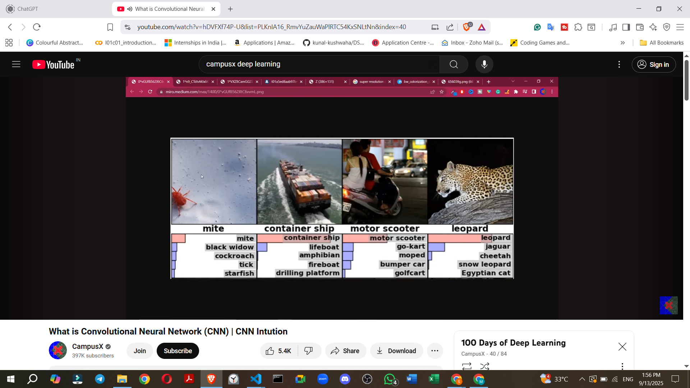

* **Object Localisation**: Identifying the presence and **exact location of a specific object** within an image by drawing a rectangular bounding box around it.

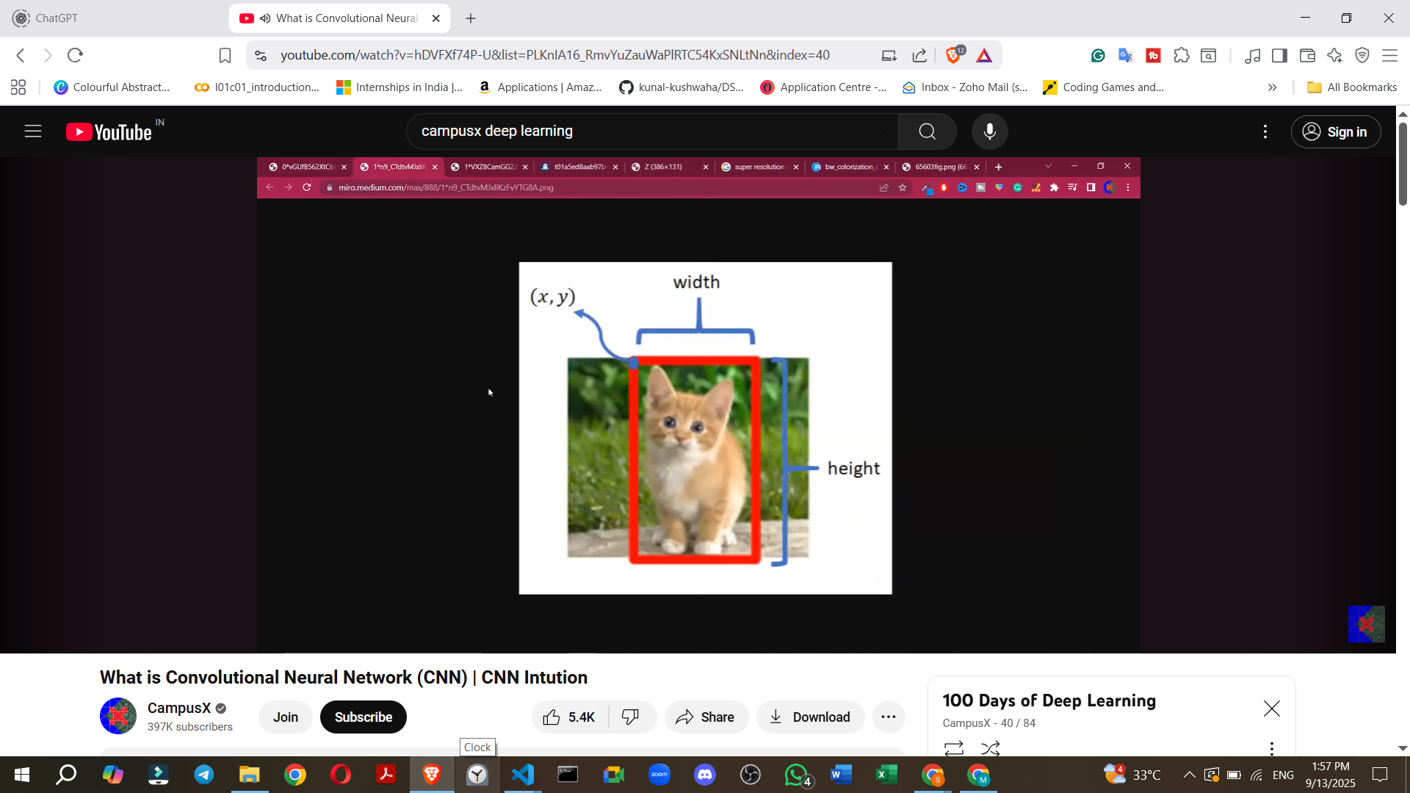

* **Object Detection**: A more complex task that involves identifying **all objects** within an image, locating them with bounding boxes, and also providing a **probability score** indicating the confidence of detection.
  + **Example**: Crucial for technologies like **self-driving cars** to detect pedestrians, other vehicles, and traffic signs.

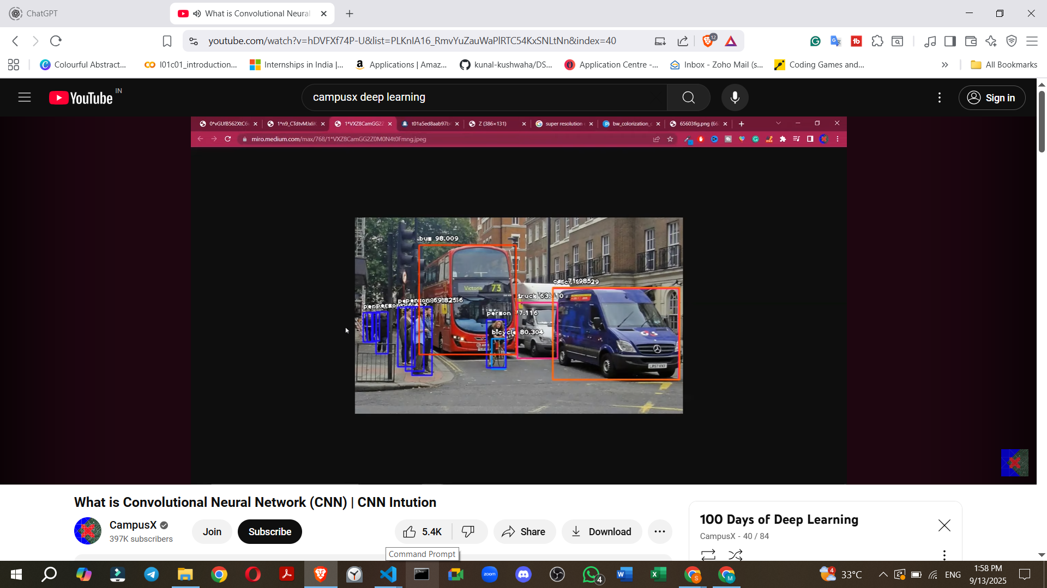

* **Face Detection and Recognition**:
  + **Example**: Used in modern **smartphone cameras** for unlocking devices or applying effects.

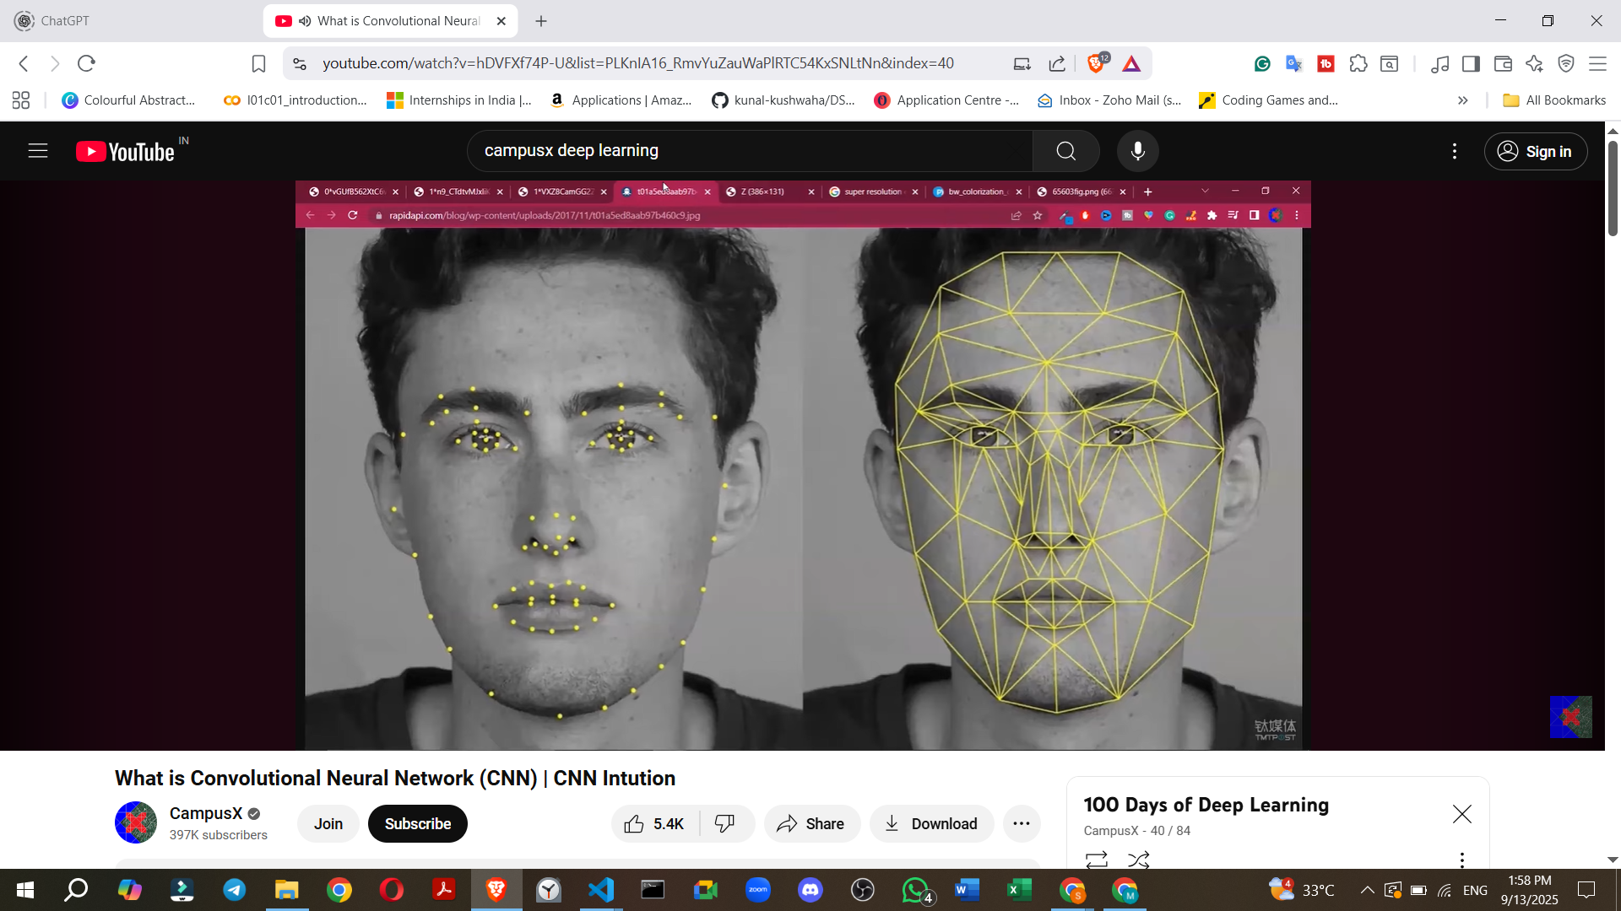

* **Image Segmentation**: Dividing an image into multiple segments or regions, often based on semantic meaning.
  + **Example**: Separating a **tiger from its background** in an image, useful for further image processing or analysis.

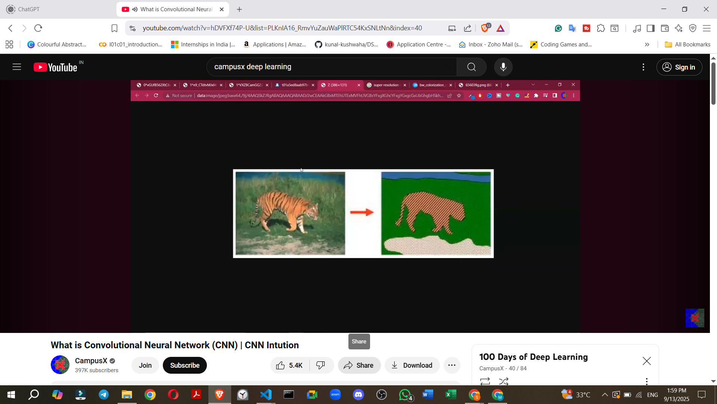

* **Super-Resolution**: Enhancing the quality and **increasing the resolution of low-resolution images**.

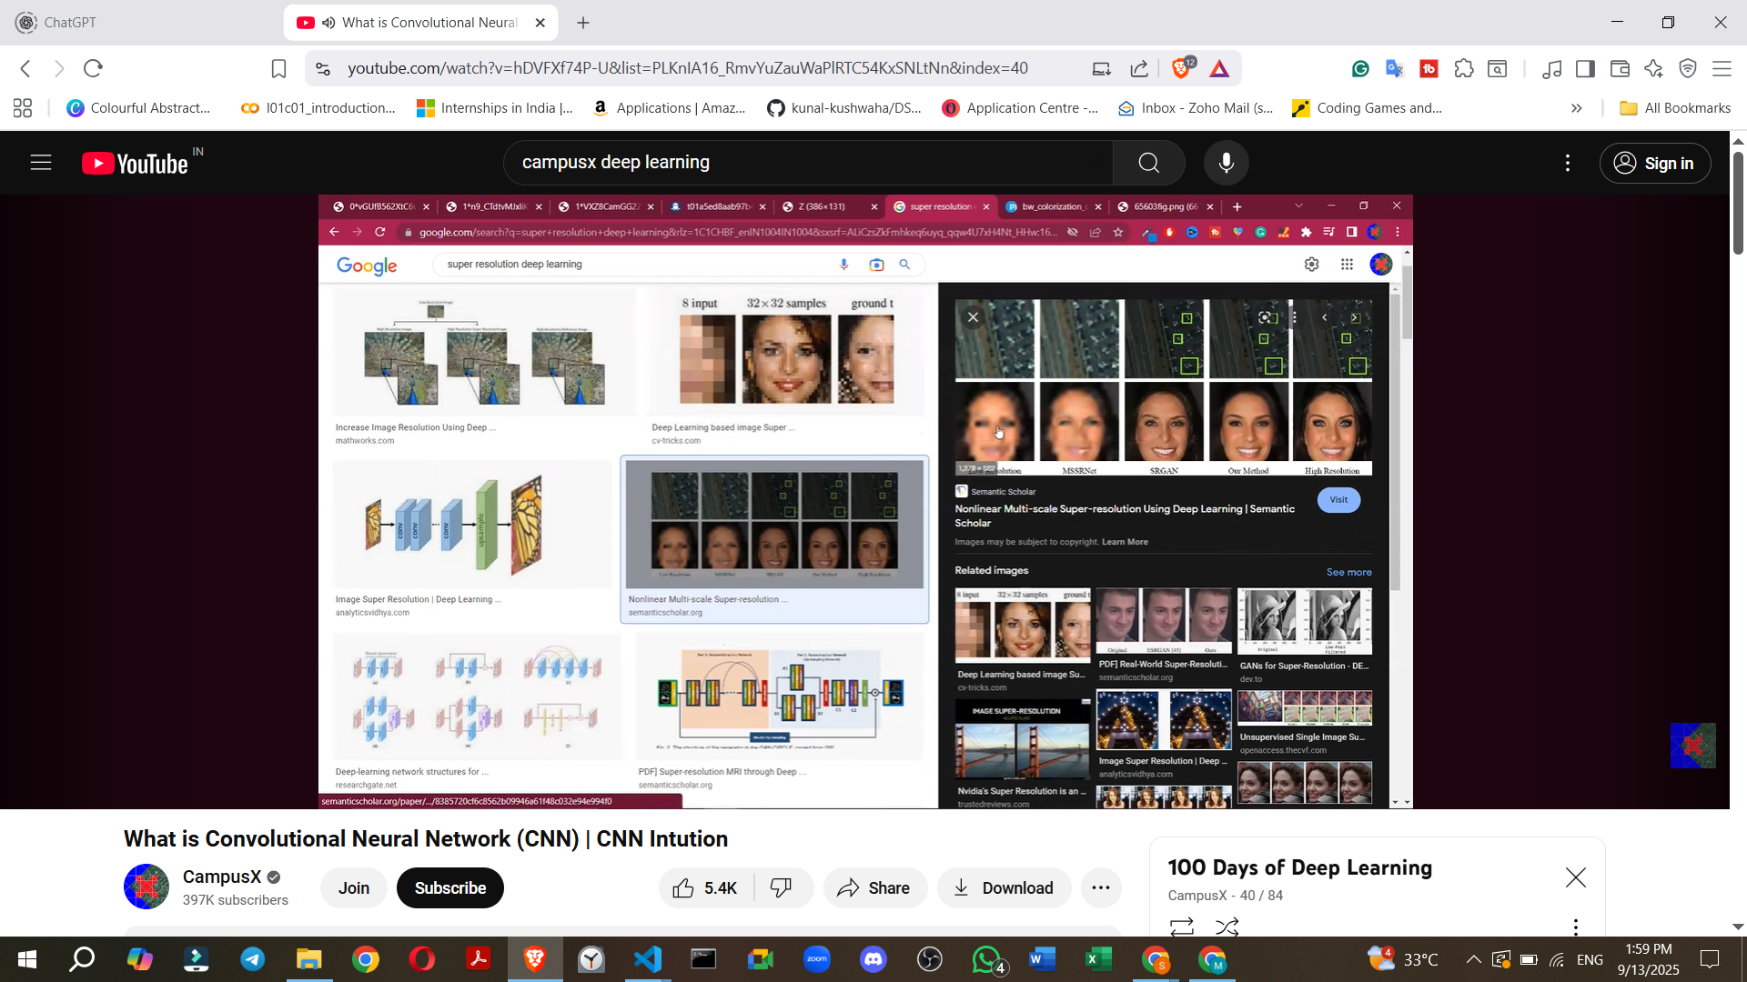

* **Image Colorisation**: Converting **black-and-white photos or videos into color**.
  + **Example**: Reviving old family photos or classic movies by adding color.

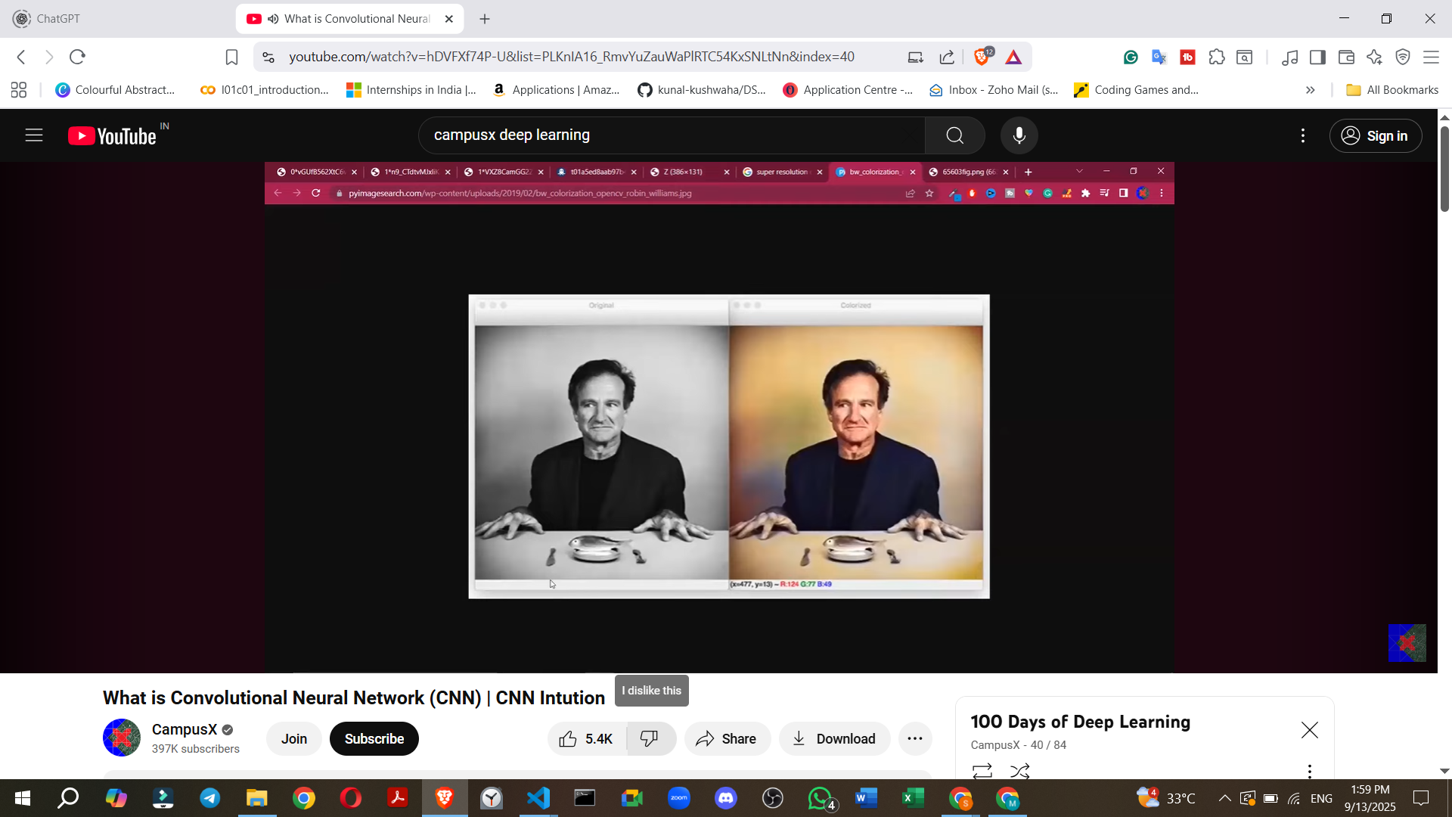

* **Pose Estimation**: Detecting the **current pose of a human body** from a camera feed.
  + **Example**: Used in fitness applications to track exercise movements (e.g., yoga poses) or in gaming consoles like **Microsoft Kinect or PlayStation** for interactive gameplay.

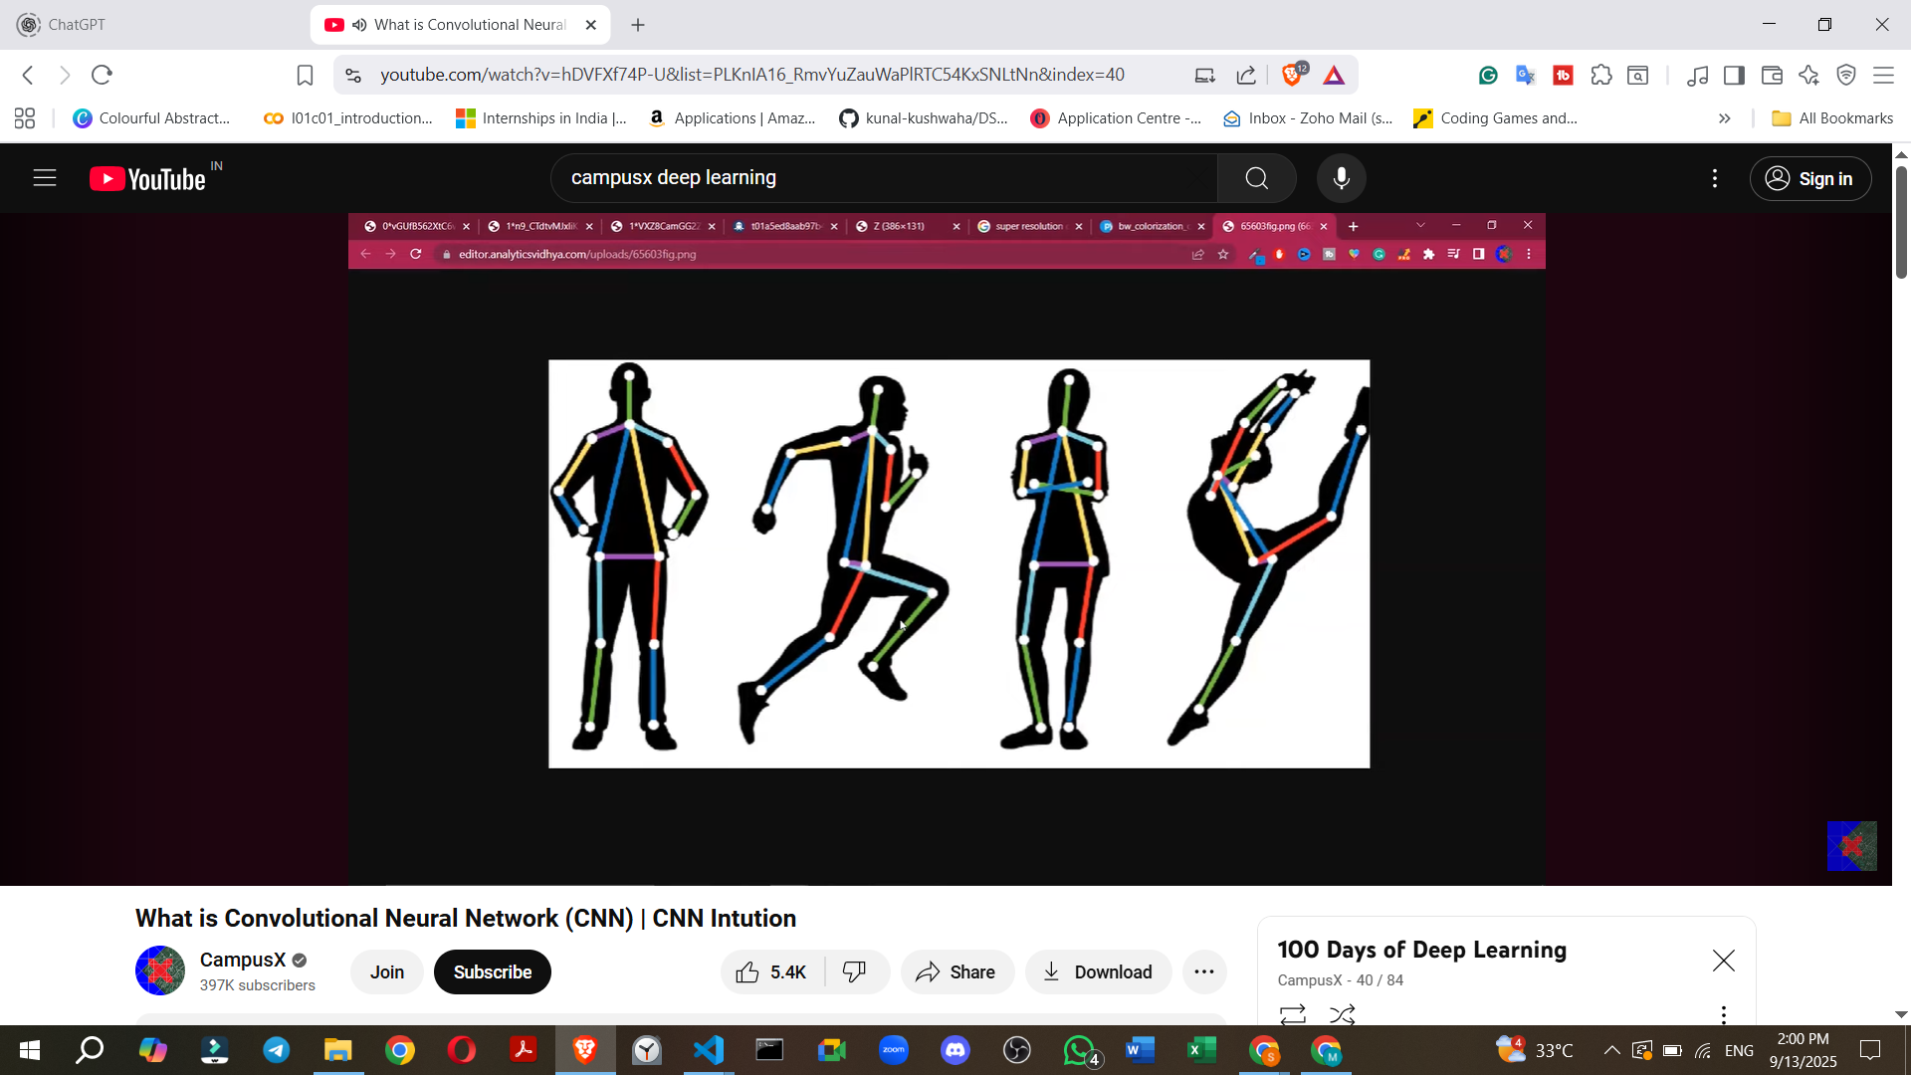

—----------------------------------------------------------------------------------------------------------------------

## **6. 📊 Famous CNN Architectures**

* **LeNet-5 (1998)** → Handwritten digits.
* **AlexNet (2012)** → ImageNet competition, deeper CNN, ReLU, dropout.
* **VGGNet (2014)** → Small 3×3 filters, very deep.
* **GoogLeNet (Inception, 2014)** → Inception modules, parallel filters.
* **ResNet (2015)** → Skip connections (solves vanishing gradient).
* **EfficientNet (2019)** → Scales depth, width, resolution efficiently.
* InceptionNet

**Transfer Learning**: An important concept involving the use of pre-trained models

## **10. 🧑‍💻 Python Example (Keras CNN)**

import tensorflow as tf

from tensorflow.keras import datasets, layers, models

# Load CIFAR-10 dataset

(x_train, y_train), (x_test, y_test) = datasets.cifar10.load_data()

x_train, x_test = x_train / 255.0, x_test / 255.0 # Normalize

# Build CNN

model = models.Sequential([

layers.Conv2D(32, (3,3), activation='relu', input_shape=(32,32,3)),

layers.MaxPooling2D((2,2)),

layers.Conv2D(64, (3,3), activation='relu'),

layers.MaxPooling2D((2,2)),

layers.Conv2D(64, (3,3), activation='relu'),

layers.Flatten(),

layers.Dense(64, activation='relu'),

layers.Dense(10, activation='softmax')

])

# Compile & Train

model.compile(optimizer='adam', loss='sparse_categorical_crossentropy', metrics=['accuracy'])

model.fit(x_train, y_train, epochs=10, validation_data=(x_test, y_test))

# Evaluate

test_loss, test_acc = model.evaluate(x_test, y_test)

print(f"Test Accuracy: {test_acc:.2f}")

✅ This is a **complete CNN overview**: intuition, math, components, architectures, advantages, disadvantages, applications, and example code.

Would you like me to also create a **step-by-step diagrammatic flow (with visuals)** of CNN operations (Convolution → ReLU → Pooling → Flatten → Dense) for easier teaching?

# **Project: Cat Vs Dog Image Classification Project | Deep Learning Project | CNN Project**

<https://www.kaggle.com/datasets/salader/dogsvscats>

[class 10 cnn_project_cat_vs_dog.ipynb](https://colab.research.google.com/drive/1blL2sdkL6HMKlZjFM8MaXkloReur6S-9?usp=drive_link)

**1. Project Overview and Introduction**

* **Goal:** To build a **Dog vs Cat Classifier** using a Convolutional Neural Network (CNN) model.
* **Functionality:** The model should classify an input photo as either containing a dog or a cat.
* **Learning Context:** This project continues the deep learning playlist, applying concepts like CNNs and backpropagation.
* **Approach:**
  + All code will be written from scratch.
  + A custom CNN architecture will be built.
  + Discussion on how to improve model performance if it's not good.
  + Demonstration of predictions on unseen data.
* **Recommendation:** Viewers are encouraged to code along for better understanding.

**2. Data Acquisition and Initial Setup**

* **Dataset Source:** Kaggle's "Dogs vs Cats" dataset.
* **Dataset Structure:**
  + Downloaded as a ZIP file.
  + Unzips into two main folders: test and train.
  + Each of these folders further contains cats and dogs subfolders, organising images by class.
* **Tools & Environment:**
  + **Keras:** Used for the entire CNN classification task.
  + **Google Colab:** Recommended for development, especially if a local machine lacks a GPU, which is crucial for faster training.
* **Setting up Kaggle API in Google Colab (for data download):**
  + **Question:** How to get the data into Google Colab efficiently?
  + **Solution:** Use the Kaggle API directly in Colab.
    - Navigate to your Kaggle account and download the kaggle.json file.
    - Upload this kaggle.json file to your Google Colab environment.
    - From the Kaggle dataset page, copy the API command.
    - Run specific commands in Colab:
      * Two preliminary commands are needed before the API command (exact commands not transcribed, but implied for setting up Kaggle environment).
      * Execute the copied Kaggle API command to download the dataset.
  + **Benefit:** This method avoids downloading to local machine and then uploading to Colab, which is time-consuming for large datasets.

============================================================================================================================================

# **What is Transfer Learning**

**1 Deep Learning and its Challenges**

* Deep Learning models are **data-hungry**, requiring a large amount of labelled data for training (e.g., 10,000 images).
* Collecting such data can involve scraping images, but **labelling each image is difficult, requires manual labour, and is costly** for companies.
* Training Deep Learning models, especially on large datasets, **takes a significant amount of time**.
* Due to these problems (data requirements and training time), people generally do not prefer to train their own Deep Learning models from scratch.

**2. Pre-trained Models as a Solution**

* The **solution to the challenges of training custom models is using pre-trained models**.
* The source refers to a previous video that discussed ImageNet, a very large dataset of daily objects and animals, containing around **1.4 million images across 1000 categories** (e.g., different dog breeds).
* An annual competition called ILSVRC (ImageNet Large Scale Visual Recognition Challenge) was organised on the ImageNet dataset.
* Models like VGG, ResNet, and InceptionNet emerged from this competition, demonstrating high performance after being trained on ImageNet.
* **Pre-trained models are CNN models trained on a different, large dataset** (like ImageNet). They have "learned" from this previous large dataset and can be used in other projects.

**3. The Problem with Pre-trained Models and the Emergence of Transfer Learning**

* A potential problem with pre-trained models is that the specific classes required for a new project might **not be present in the 1000 classes** the model was originally trained on.
* For example, if a project requires classifying images as "phone" or "tablet," and these specific classes are not among ImageNet's 1000 classes, directly using the pre-trained model might not work.
* **Transfer Learning is introduced as the solution to this problem**.

**4. What is Transfer Learning?**



* **Transfer Learning is a machine learning technique that focuses on storing knowledge gained while solving one problem and applying it to a different but related problem**.
* It leverages the benefits of pre-trained models by using a CNN trained on another dataset (which saves cost and time on data collection and training).
* Transfer Learning has become a significant area in machine learning since 2015-2016.
* Andrew Ng stated that, besides supervised learning, **Transfer Learning will be the next big thing to advance machine learning in the industry**, even surpassing unsupervised and reinforcement learning in potential impact.
* Transfer Learning is inspired by real-life situations:
  + Learning to ride a bicycle makes learning to ride a motorcycle easier because the brain transfers balancing knowledge.
  + Knowing how to play a musical instrument like the violin makes learning a related instrument like the guitar easier due to an understanding of musical notes.
* In essence, Transfer Learning is the computer science integration of this idea: **applying knowledge from one domain to another**.
* [class 14 What is Transfer Learning? Transfer Learning in Keras | Fine Tuning Vs Feature Extraction](https://docs.google.com/document/d/1xS9zYtiX22eEJ2sErLxMUTXgnbmU1I_Gx1-12kkKlgE/edit?usp=sharing)
* [class 14.3 transfer_learning_finetuning.ipynb](https://drive.google.com/file/d/1xHaG2C6NXBV8_Lke3l0mUrrz_1PLeJu9/view?usp=drive_link)

======================================================================

<https://www.datacamp.com/tutorial/introduction-to-convolutional-neural-networks-cnns>

<https://www.geeksforgeeks.org/machine-learning/introduction-convolution-neural-network/>

<https://medium.com/@draj0718/convolutional-neural-networks-cnn-architectures-explained-716fb197b243>